Episode 77 - Prehistoric Survival Part 2

Doggerland, Stroregga tsunami

Doggerland- The Europe That Was, Benjamin Kessler, National Geographic https://education.nationalgeographic.org/resource/doggerland/

Doggerland: Lost ‘Atlantis” of the NOrth Sea gives up it’s ancient secrets, Daniel Boffey, The Guardian https://www.theguardian.com/science/2021/aug/01/doggerland-lost-atlantis-of-the-north-sea-gives-up-its-ancient-secrets

Letter from Doggerland, Jason Urbanus, Archology https://www.archaeology.org/issues/461-2203/letter-from/10357-doggerland-mesolithic-submerged-landscape#art_page6

Study finds indications of life on Doggerland after devastating tsunamis, Esther Addley, The Guardian https://www.theguardian.com/uk-news/2020/dec/01/evidence-life-on-doggerland-after-devastating-tsunamis-study

Tiny island survived tsunami that helped separate Britain and Europe, Michael Marshall, New Scientist https://www.newscientist.com/article/2261173-tiny-island-survived-tsunami-that-helped-separate-britain-and-europe
/
Bondevik, S., F. Lovholt, C. Harbitz, J. Mangerud, A. Dawson, J.I. Svendsen. 2005. The Storegga Slide tsunami–comparing field observations with numerical simulations. Marine and Petroleum Geology. 22(1–2): 195–208. https://www.sciencedirect.com/science/article/abs/pii/S0264817204001904?via%3Dihub

Doggerland: How did the North Sea’s Atlantis Sink? Alexander Freund, DW News https://www.dw.com/en/doggerland-how-did-the-atlantis-of-the-north-sea-sink/a-55960379

Roughly 12,000 years ago, when the last major ice age reached its end, huge swaths of the North Sea were above sea level. It was an area covered with gently sloping hills, marshland, heavily wooded valleys, and swamps. This area we now call Doggerland due to the 17th century Dutch “Dogger” fishing boats that sailed the Dogger bank area of the North Sea where Doggerland used to sit.

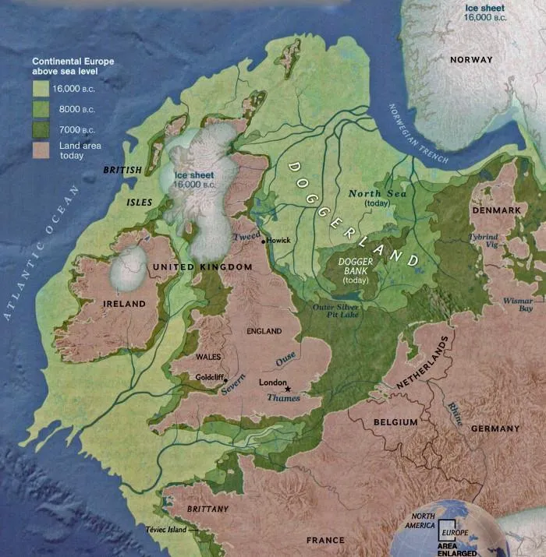
Doggerland, Explorer’s Web

Mesolithic humans and neanderthals populated the areas, mainly hunter gatherers that were nomadic and migrated with the seasons. Humans had inhabited the area from 10,000-6,000 BC, but neanderthals had inhabited the area in millenia prior, so the landmass was exposed for a very long time. It was thought that by the time humans arrived in this area, it was one of the richest environments in Europe, covered with wild game, forests, grasslands, and wetlands. Humans were mainly nomadic and “with lifestyles which are short, brutish and nasty.” but that they may have been able to settle semi-permanently in coastal areas that were richer in resources. The wide open grassy plains of doggerland were ideal grazing ground for large herds of animals such as reindeer, irish elk, aurochs (giant prehistoric bison), and mammoths who were prey for cave lions, saber-tooth tigers, cave hyenas, wolves, and hominids.

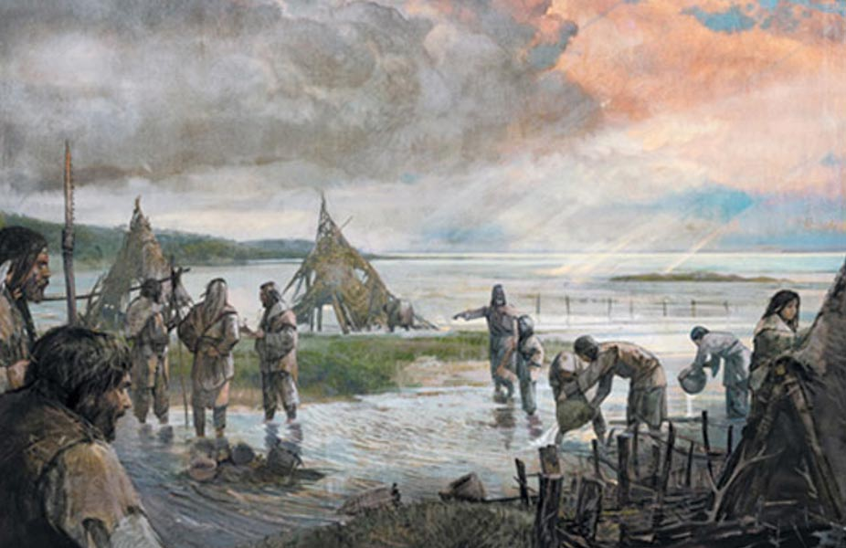
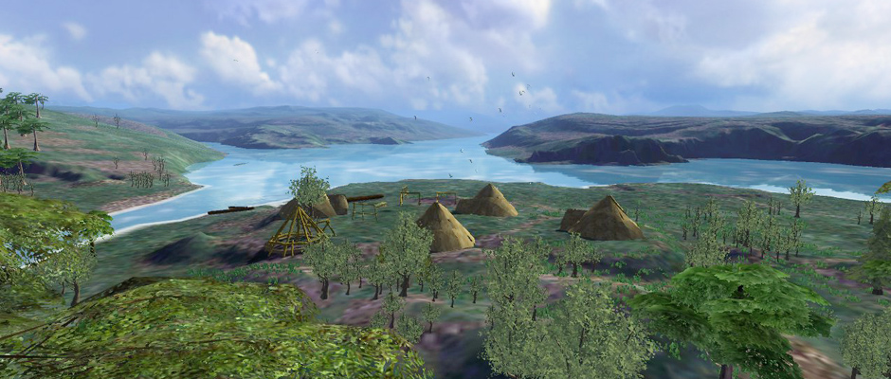
Illustration of what a doggerland nomadic settlement may have looked like, Ancient origins and Orkney International Science festival

Slowly, the Doggerlanders were supposedly flooded out of seasonal hunting grounds as glacier locked water slowly melted at the end of the ice age, until around 6,000 years ago, these people were forced onto the higher grounds of the Netherlands and Great Britain. Its likely too, however, that a tsunami around 8,000 years ago really forced its inhabitants to leave Doggerland in a hurry, and likely caused catastrophic damage to those who couldn’t escape. This tsunami was estimated to occur between 6100-6,200 BC and was caused by an underwater landslide off the coast of Norway.

Fishermen have been dredging up evidence of this now underwater world as early as 1931 when the trawler Colinda dredged up a lump of peat containing a spear point, which was later dated to 10,000-4,000 BC. Further research on the peat indicated that it had formed in a freshwater environment, not a marine one, indicating that whoever had lost the spear was traveling on land, not over sea. This spurred archeological interest in the region and supported theorization that the North Sea had been much lower during these time periods, evidenced by the remnants of ancient forests that would occasionally protrude out of tidal flats in the UK.

The original doggerland spear point discovered in 1931, Norfolk Heritage Explorer

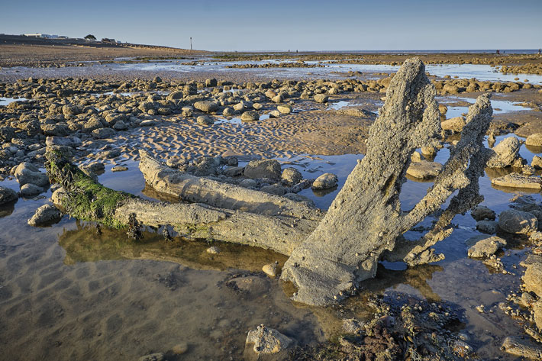
Evidence of odggerland’s former forests, Archeology Magazine.

British and Dutch archeologists have been bringing the submerged history to the surface, though residents of these areas and fishermen have been finding tree stumps and the skulls of prehistoric mammals in the North Sea for years. Using modern seismic survey data acquired by oil companies drilling in the North Sea, scientists have been able to construct a digital model of the 18,000 square miles of Doggerland before it was flooded. The floor of the North Sea is now recognized as the largest well-preserved prehistoric archaeological landscape in the world. Modern fishermen often find ancient bones and tools that date to about 9,000 years ago. Artifacts dredged up include deer bone with arrowheads embedded in them, petrified hyena droppings and mammoth molars, Auroch bone fragments with etching art, and fragments of skulls of Neanderthals.
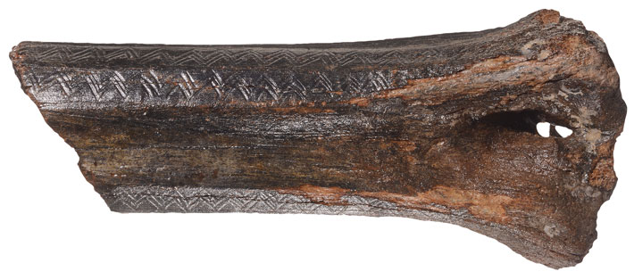
13,000 year old Auroch or Bison bone etched with zigzag design found in Doggerland,https://www.archaeology.org/issues/461-2203/letter-from/10357-doggerland-mesolithic-submerged-landscape#art_page6

In the Netherlands, citizen scientists now assist in gathering evidence of Doggerland on new reclaimed coastlines that the Netherland’s dredges up to create protective barriers to their low lying country from sea level rise. Some examples of beach finds include a 50,000 year old flint tool, human skull fragments with cut marks caused by defleshing (thought to be part of a burial ritual), and hyena jaws. Because of the anoxic or oxygen-free conditions of the North Sea’s seafloor, bones are relatively well preserved, and scientists can even extract DNA from human skeletal remains, providing info on sex, age, physical characteristics, diet, and geographic origins. There is a threat of this massive archeological site being lost, however as renewable energy efforts aims to cover the North Sea with wind farms, and networks of cables will create irreparable damage to the archeological sites there.

The Storegga tsunami, which occurred in 6100-6200 BC (8,200 years ago), and was assumed to have been a disaster for the peoples that lived in the area at the time. A tsunami is a series of waves in a water body caused by the displacement of a large volume of water, generally in an ocean or large lake. Earthquakes, volcanic eruptions, landslides, glacier calvings, and meteorite impacts can cause a tsunami. The Storegga tsunami was triggered by enormous underwater landslips or a submarine landslide off the coast of Norway. An estimated 3,500 cubic kilometers of rock and debris plunged into water depths over a stretch of 290 kilometers The waves from the resulting tsunami reached 10-12 m above sea level or higher. For example, the Shetland Islands experienced waves above 20 m, and in England, effects of the wave can still be traced 40 km from the present day coastline. Dr. Vincent Gaffney, a professor of landscape archeology at the University of Bradford stated of the event, “If you were standing on the shoreline on that day, 8,200 years ago, there is no doubt it would have been a bad day for you. It was a catastrophe. Many people, possibly thousands of people, must have died.” Dogger Bank, one of the highest points on the landscape, was one of the last pieces of dry land to survive, where it temporarily existed as an archipelago of islands.

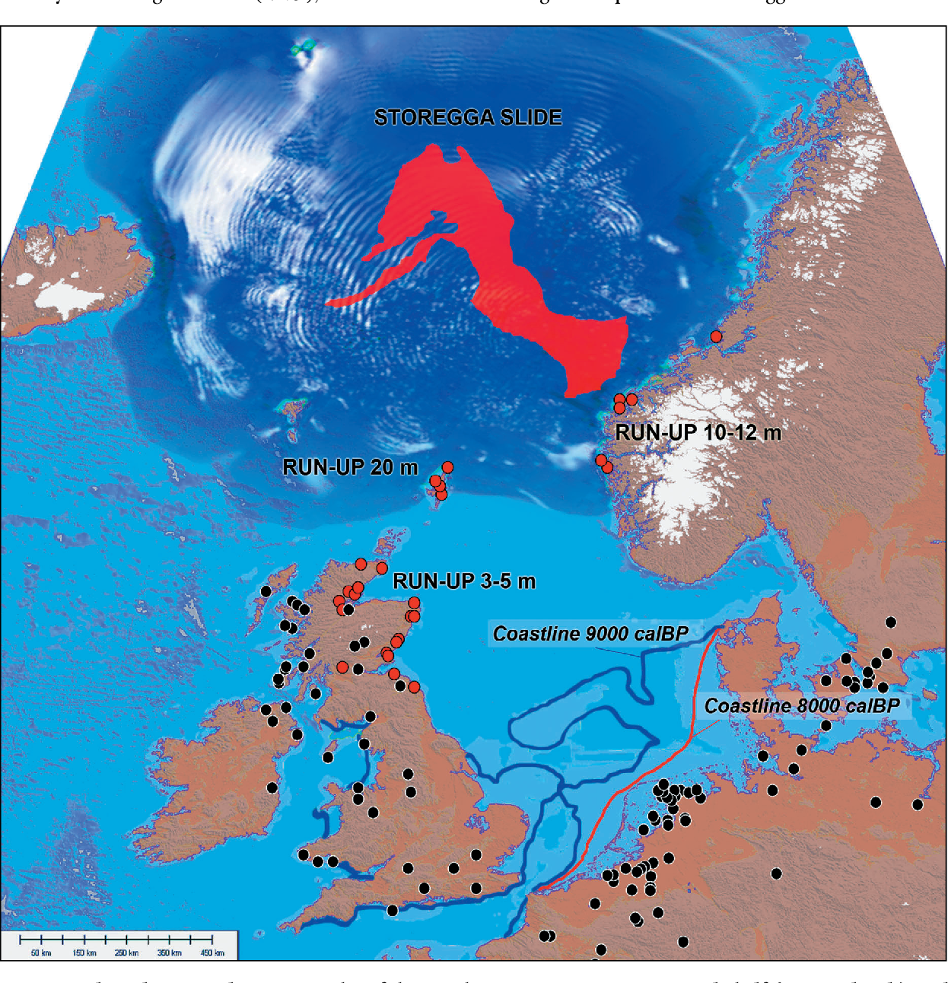
Areas of Doggerland thought to have been impacted by the tsunami, red dots represent tsunami impacted sites…https://www.semanticscholar.org/paper/The-catastrophic-final-flooding-of-Doggerland-by-Weninger-Schulting/d026d23aaef8fdbc5da8503f6eefe31e4d31e6f5/figure/4

The Storegga tsunami is thought to be the largest tsunami event to hit the area since the beginning of the Holocene era. Many researchers have found evidence of deposits related to the tsunami in areas as far away as Greenland. Sedimentary evidence containing both shell and tree matter found in Doggerland off the north coast of Norfolk contained flood evidence, the first from the southern North Sea. Research showed that in places the tsunamis swept up to 25 miles inland along valleys and low lying areas, but that dense woodlands and hills may have protected other parts of the region. Later sediments suggest the area was above water again at some point after flood water receded Simulations of the tsunami suggested that it couldn’t have swamped Doggerland in its entirety. While parts of Doggerland was inundated, the archipelago survived for millennia until it was swallowed by rising sea levels and climate change, taking it’s mysterious prehistoric world with it.

Rising Star Cave System - Pre Human Cavers

Ancient Human Relatives May Have Buried THeir Dead, Will Sullivan, Smithsonian Magazine https://www.smithsonianmag.com/smart-news/ancient-human-relatives-may-have-buried-their-dead-180982308/

Unknown: Cave of Bones, Netflix, https://www.netflix.com/title/81473682
Ancient Human Relatives Buried Their Dead in Caves, New Theory Claims, Carl Zimmer, New York Times https://www.nytimes.com/2023/06/05/science/ancient-humans-homo-naledi-buried-dead.html

The Latest on Homo naledi, John Hawks, American Scientist https://www.americanscientist.org/article/the-latest-on-homo-naledi

Were small-brained early humans intelligent? Row erupts over scientist’s claim, The Guardian https://www.theguardian.com/science/2023/jul/22/small-brained-early-humans-homo-naledi-cleverer-storm

A research team’s finding of pre-human burial sites was publicly lauded. Then came the peer reviews. Maya Fazel-Zarandi and Julian Hartman-Sigall, The Daily Princetonian, https://www.dailyprincetonian.com/article/2023/07/princeton-ancient-human-relatives-buried-in-south-africa-national-geographic-anthropology-professor-peer-review

The Five Animals That Grieve, Harper Collins https://www.harpercollins.com/blogs/harperkids/the-five-animals-that-grieve

The truth about animal grief, Zoe Cormier, BBC Earth https://www.bbcearth.com/news/the-truth-about-animal-grief

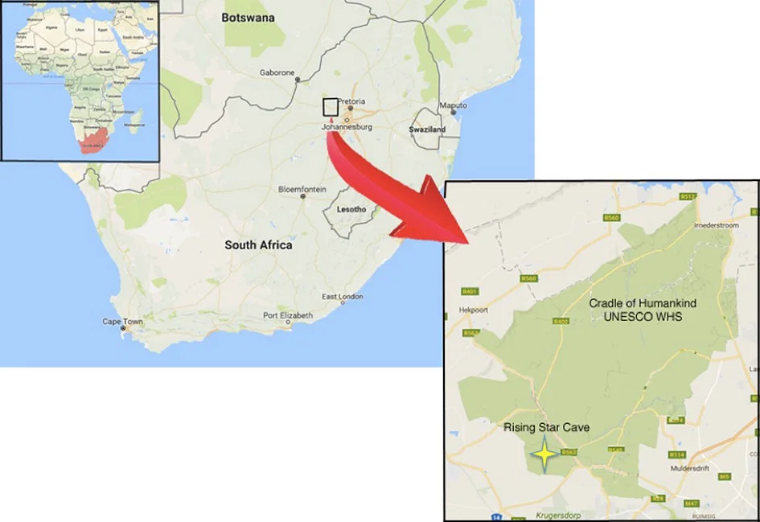
Location of Rising Star cave, https://www.worldhistory.org/image/6877/rising-star-cave-location-map/#google_vignette

In South Africa, hobby spelunkers Rick Hunter and Steve Tucker found something unexpected in the Rising Star Cave System. The cave had been well mapped, but in 2013 Hunter and Tucker entered a remote unmapped chamber of the cave and found the floor strewn with humanoid fossils. They were later determined to be a new species of hominid discovered, now called Homo naledi. The hominid fossils, which split from our own ancestor’s lineage over 2 million years ago, date between 236,000 and 335,000 years ago. H. naledi were a type of hominin that walked upright on two legs, stood about five feet tall, had curved fingers and toes, and had brains about a third the size of ours, with brains little bigger than those of chimpanzees. The cave, located in the UNESCO world heritage site Cradle of Humankind park, it is just one of the many early hominid sites found in this region, but it has some unique features that change our knowledge of early human evolution. The Cradle of Humankind is home to the largest concentration of hominid remains in the world.

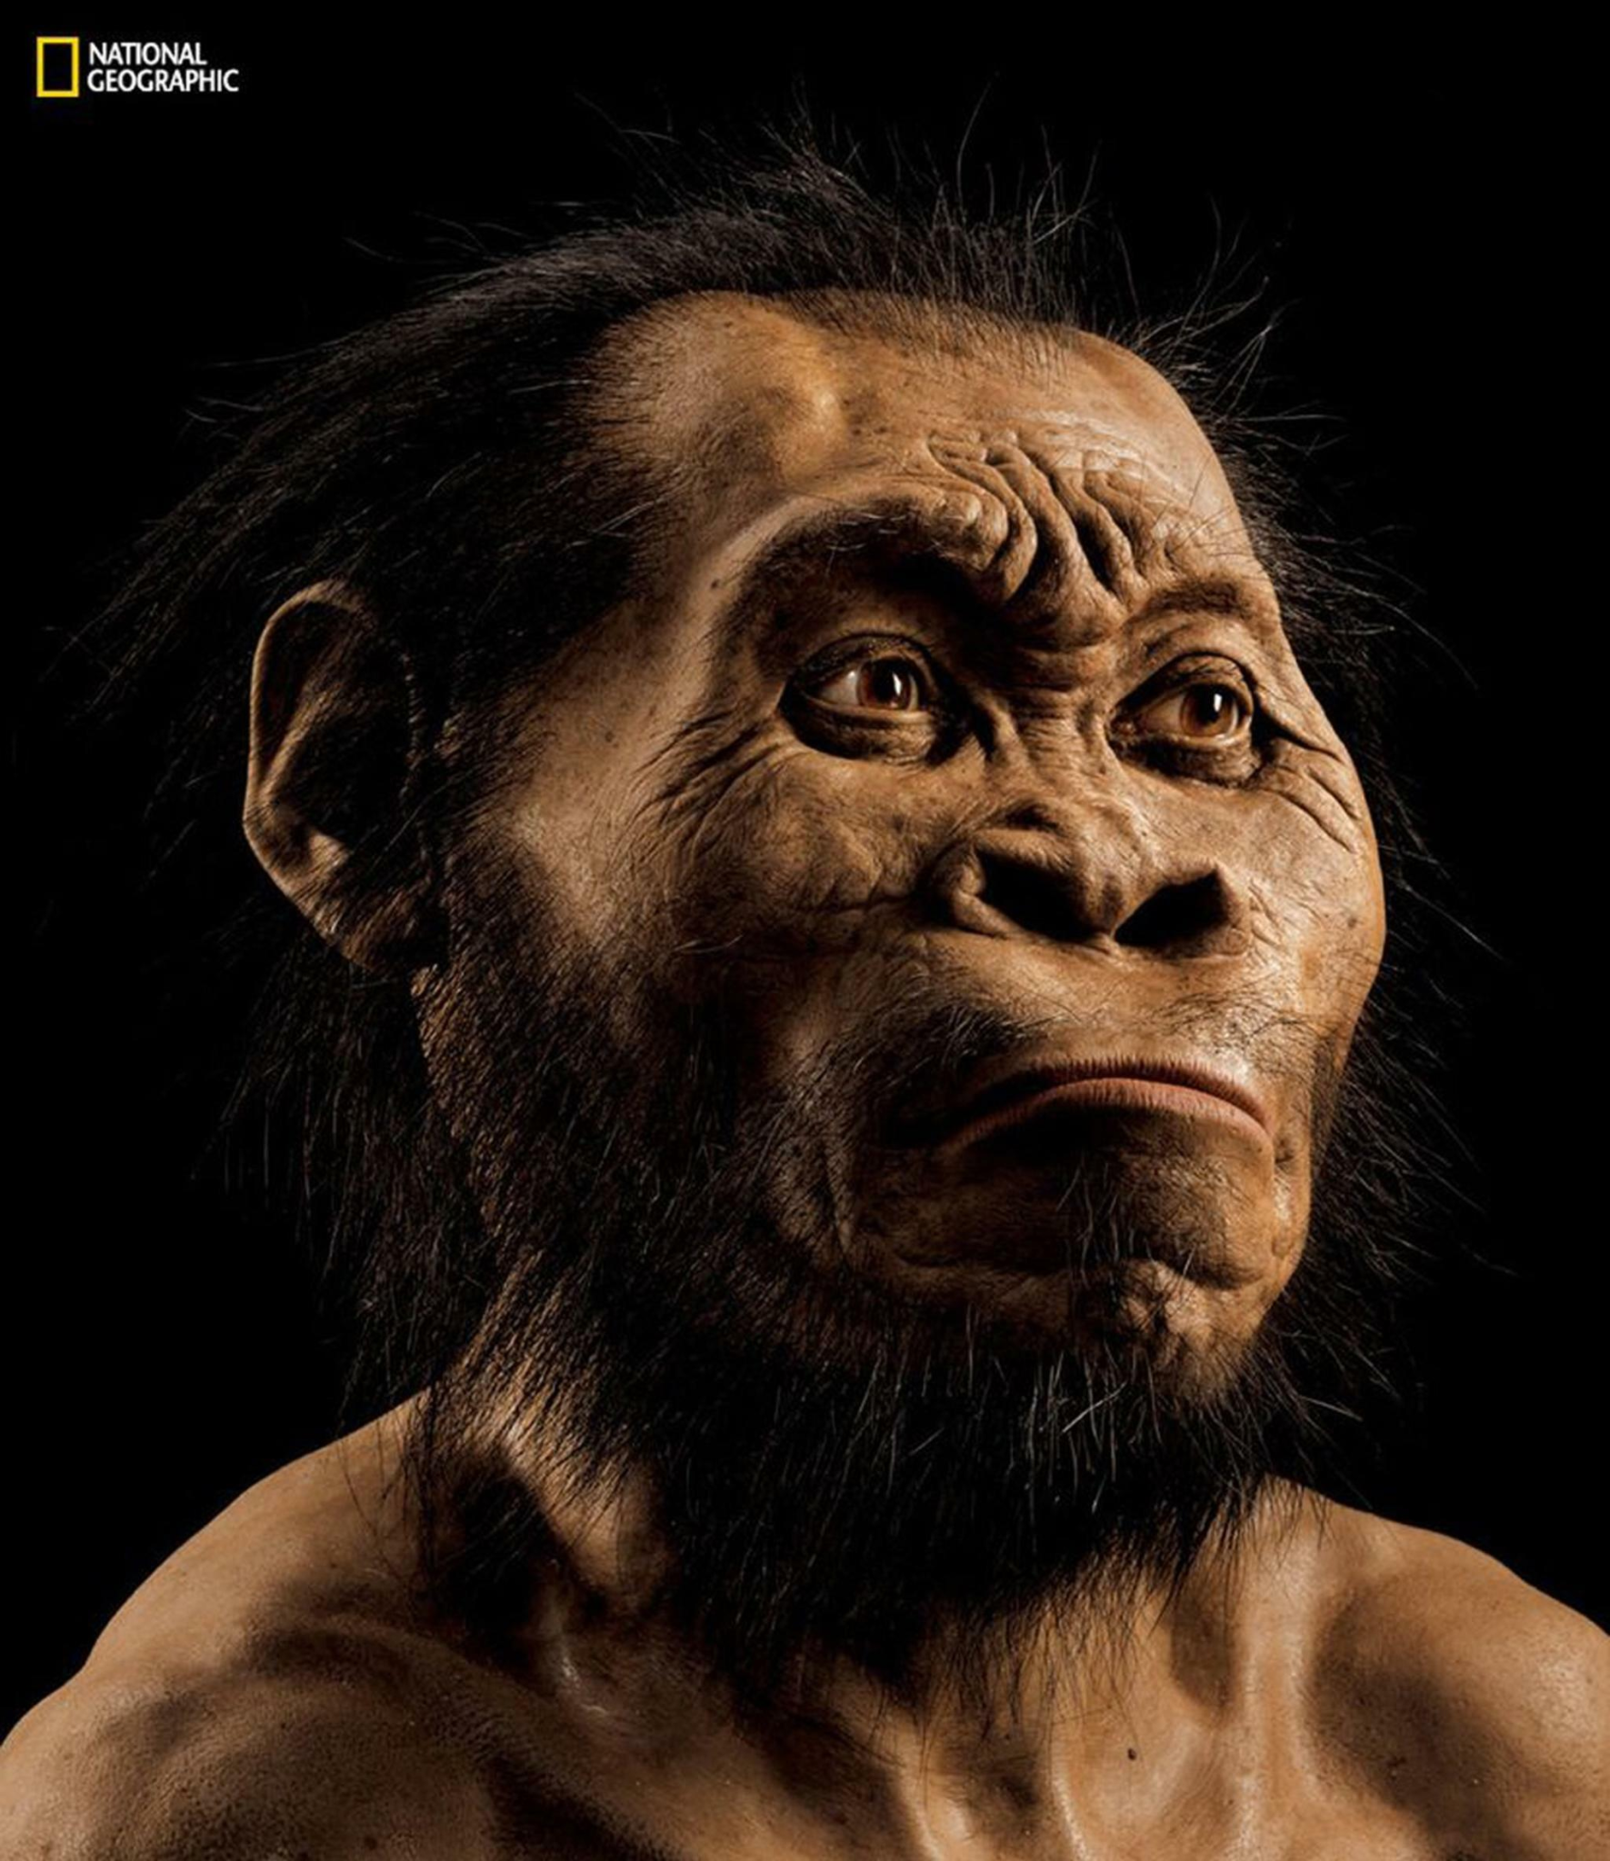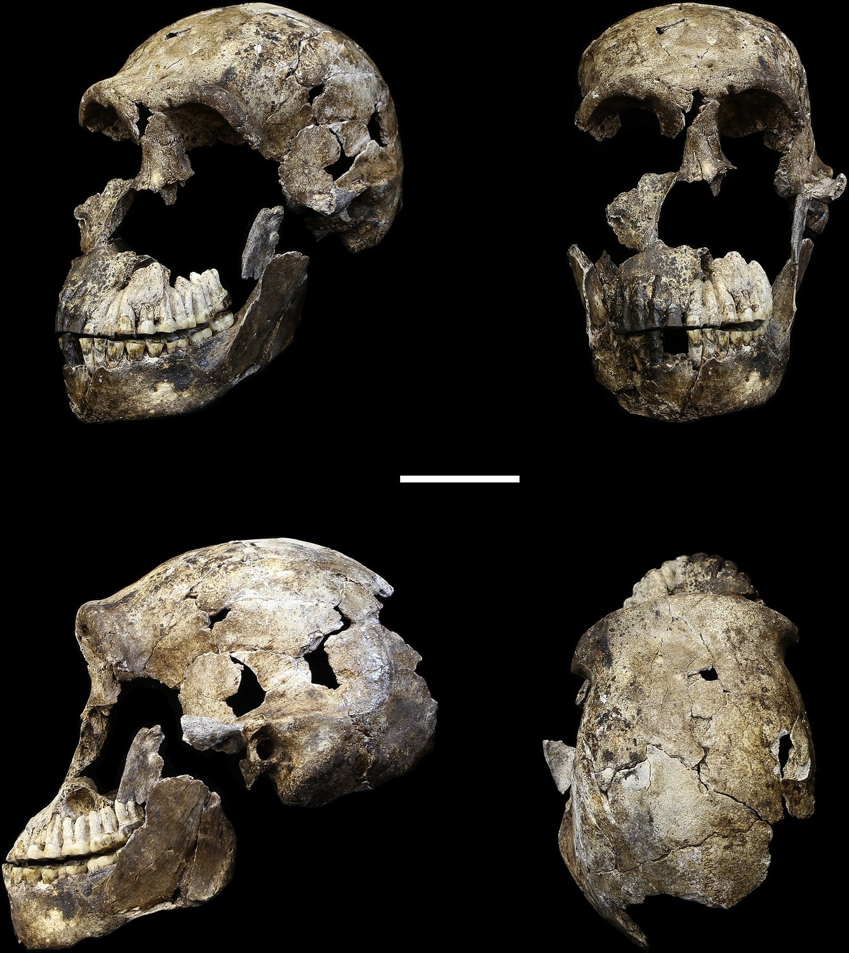
Reconstruction of Homo naledi, National Geographic
H.naledi skull, https://www.worldhistory.org/Homo_Naledi/
Quickly, paleoanthropologist Lee Berger from the University of WitwatersrandIts in South Africa began, with a team that included Hunter and Tucker, investigating the early hominids. The biggest finding from Berger’s research is that the remains in Rising Star cave were supposedly buried intentionally, making H. naledi the first hominids to bury their dead. Previously, only humans and Neanderthals have been known to bury their dead, and the oldest known human burial site dates to about 78,000 years ago, 160,000 years after the Rising Star site.
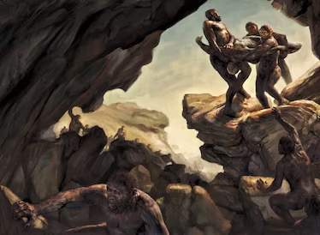
Reenactment of H. naledi burial, National Geographic

The research was not easy however, as the burial chamber in the cave was extremely difficult to reach, and requires squeezing through an almost vertical passage. The burial chamber, known as Dinaledi (or Chamber of Stars), is only accessed through a tight, vertical squeeze, indicating that if H. naledi were bringing their dead to this site, they were accomplished climbers and cavers as well. The cave is a system of complex chambers and tunnels, which extends for miles underground. “When you’re in there, it’s like you’re on a different planet,” said Tebogo Makhebela, geologist at the University of Johannesburg working with the team. Some passegways are so tight that only smaller members of the team can fit through, so an initial team of 6 female paleoanthropologists were enlisted to the project, the only ones slim enough to pass through an 18 cm wide rock gap to access Dinaledi. Berger himself only entered the chamber once, losing 55 lbs to fit through the passageway, saying that getting out was harder than getting in, and that he “almost died” but escaped with a torn rotator cuff. Only 48 humans have been documented entering the Dinaledi Chamber, which is now an active archaeological site.

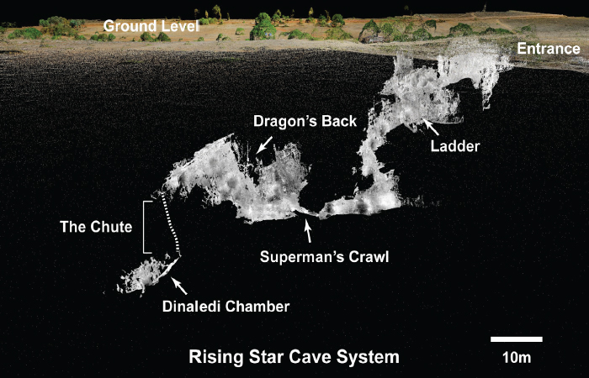
Diagram of rising star cave, https://www.ucl.ac.uk/human-evolution/news/2016/may/recording-methodologies-fossil-hominin-remains-rising-star-has-finally-been-published

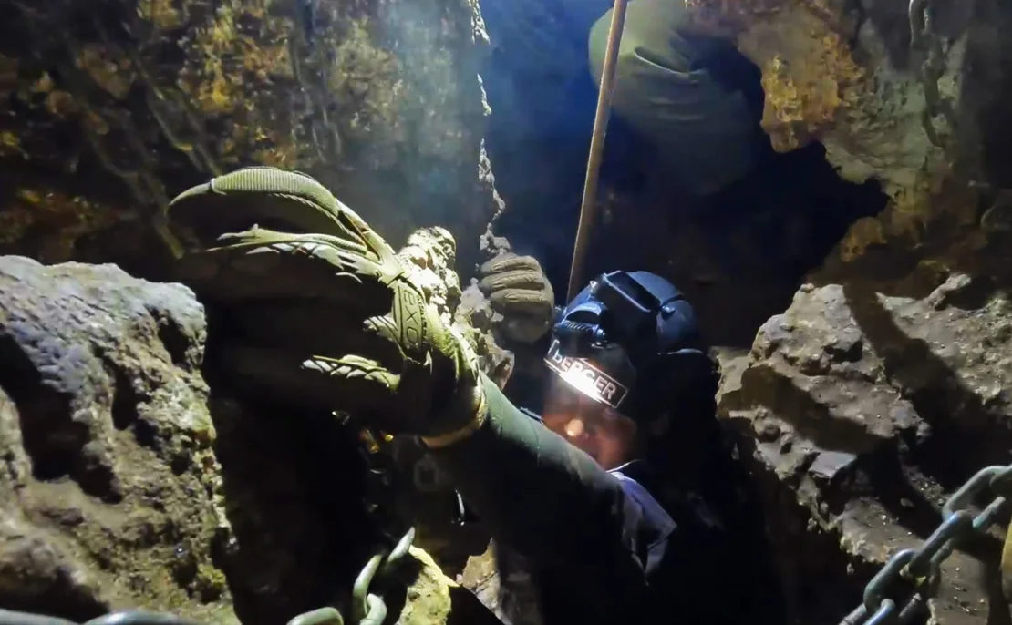
Climbing down the chute in rising star cave, https://www.cnn.com/2023/06/05/world/homo-naledi-burials-carvings-scn/index.html

While many archeologists and paleoanthropologists debate the veracity of these claims, there is some significant evidence that H. naledi was intentionally descending into this cave system to place their dead. About 1,500 bones of H. naledi were found in the cave from 27 individuals, including very young infants and elderly adults, indicating the generational nature of these burials. Berger initially thought that the bodies were deliberately left on the cave floor rather than being buried, an act archeologists call “funerary caching”. However, Layers of sediment on the floor of the burial chamber suggests that they were digging and filling holes after placing bodies within them. Two mostly complete bodies lay in oval shaped depressions, with a layer of mud around the holes but not inside them, indicating that the remains hadn’t just sunken into the sediment under their own weight. In addition, there are no other bones of medium or large animals other than H. naledi, meaning it’s likely they were physically carried there by others, not washed into the cave by natural forces such as water. Considering the tight squeezes and passages required to enter the burial chamber, it is hard to imagine all these bodies would have washed in with no bones left in other chambers higher up in the cave. The bones were also unmarked, discouraging the evidence that predators brought them down (again, as if they could even access the chamber).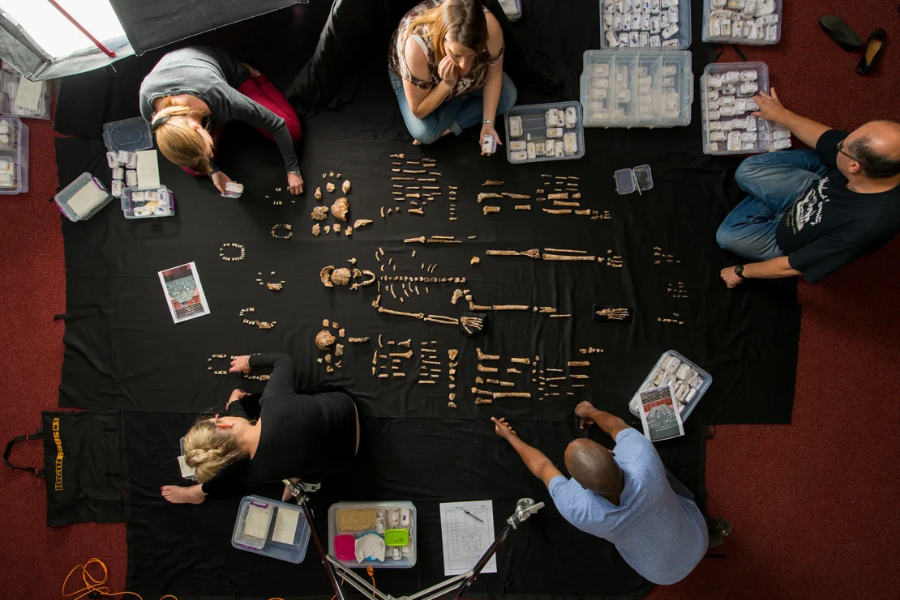
H. naledi skeleton, https://www.cnn.com/2023/06/05/world/homo-naledi-burials-carvings-scn/index.html

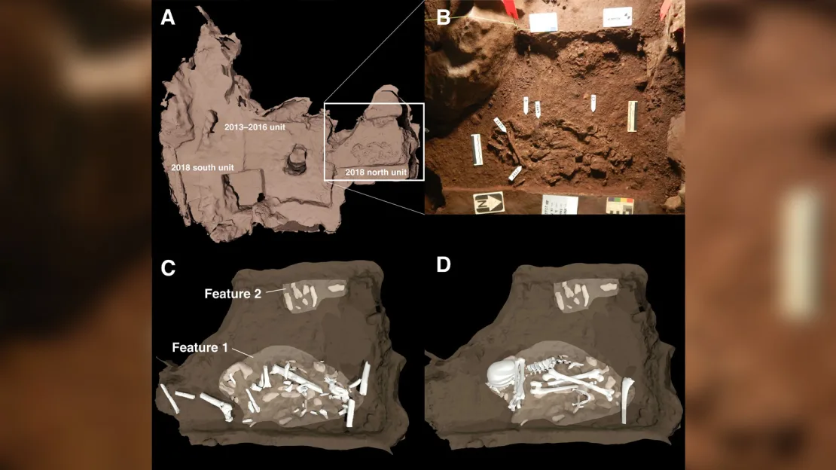
One of the burial pockets, https://www.cnn.com/2023/06/05/world/homo-naledi-burials-carvings-scn/index.html

It's also thought that they used fire to access Dinaledi, from evidence of ash in the upper chambers. Because the cave would have been very dark, almost black out conditions, it’s thought that H. naledi would have needed a light source to successfully access the chamber. There is also evidence of soot on the cave walls in the Dinaledi Chamber, including bits of charcoal in the chambers, and burned bones of turtles and rabbits. In addition, Lee Berger claims that the hominids also left markings on the burial chamber walls, however, this claim is more up to debate as the engravings have not been dated, so it’s possible they were left by modern humans that entered the cave long after H. naledi went extinct. The marks are not natural, they depict geometric patterns, squares, crosses, and Xs Recent research dates the engravings back to approximately 241,000 to 335,000 years…if these are accurately linked to H. naledi, this could represent some of the earliest evidence of symbolic behavior and artistic expression in early hominids.

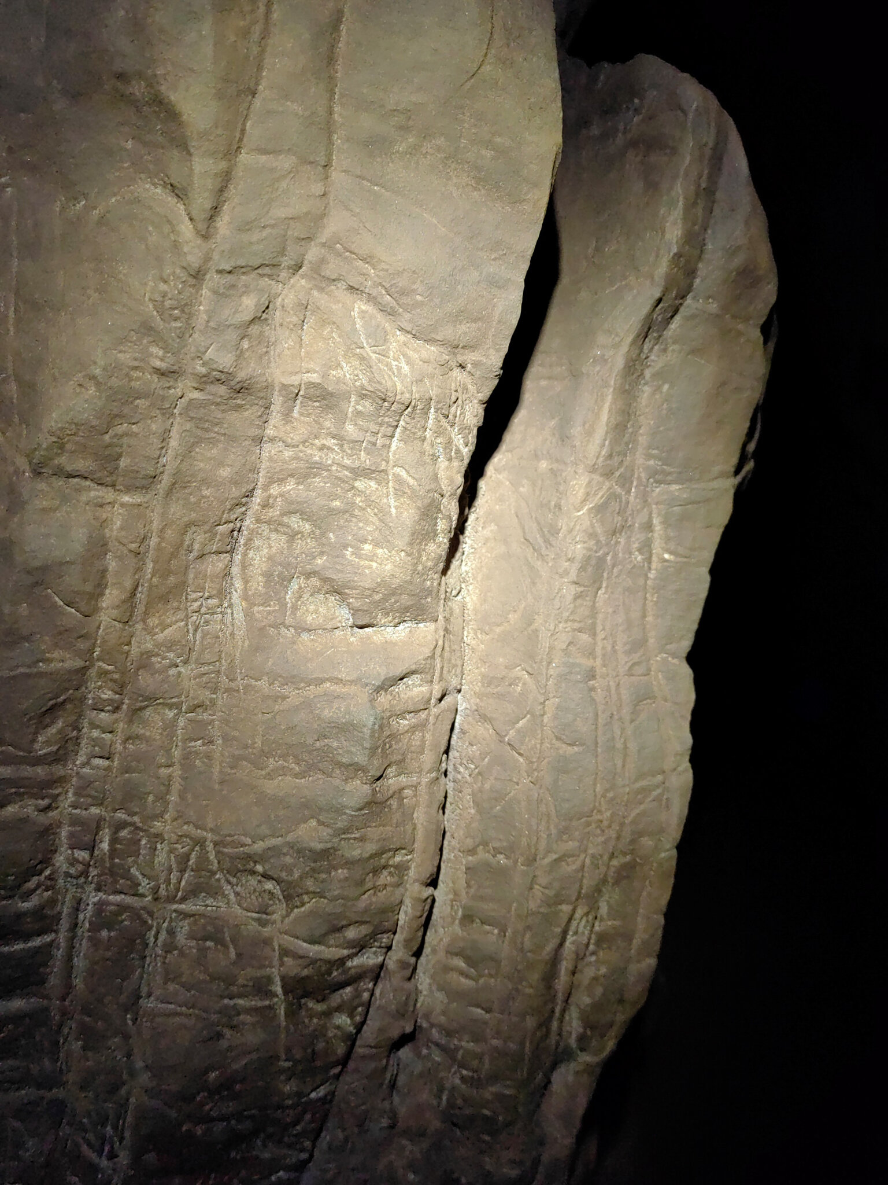
Dinaledi chamber markings, https://www.nytimes.com/2023/06/05/science/ancient-humans-homo-naledi-buried-dead.html

Project research partner and Princeton anthropology professor Agustin Fuentes stated that the complex process of entering the cave increases the thought that the bodies were at least placed in Dinaledi “You suit up and climb down into the cave, angling and squeezing yourself in. And then you come out in these spaces and you look around and think, this is not just a rock, this is not just a cave. This place meant something to the Homo naledi.” Lee Berger stated “This is something that takes a lot of time and effort to do. What you are seeing here is a repeated ritual, a response to the dead that has meaning.” Based on the number of fossils found, it’s thought that H. naledi may have been visiting the cave for hundreds of generations, moving together into the dark depths to bury the dead. This type of practice may have required some sort of language to accomplish.

That being said, there is a lot of debate over the veracity of these claims. There are other possibilities as to how the bones ended up there, such as rain or mudflow carrying them from another part of the cave, and these theories have not been fully tested. Another threat to the “burial” evidence includes that a lot of the bones are spread out and disconnected instead of collected together as intentionally placed bodies. Peer reviews of recent papers of the research state “These papers are imprudent and incomplete. These claims are inadequate, incomplete, and largely assumption based, rather than evidence based.” Another reviewer stated, “In it’s current form the paper…does not meet the standards of our field…The working hypothesis is that the features are intentional burials, and the authors seek to support this hypothesis throughout rather than test it.” Andy Herries of La Trobe University in Melbourne Australia stated “I have no issue with the idea that non-homo sapiens species disposed of their dead, but I do have an expectation that there is robust scientific evidence to support such statements before scientists go on massive media campaigns regarding these ideas.”

While there is a lot of debate over the specifics, many scientists are coming around to the evidence. Dr. Martinon-Torres, for example, believes that funerary caching was more likely than true burials, saying “Still, I think the possibility of having funerary caching with this antiquity is already stunning.” Dr. Michael Petraglia, the director for the Australian Research Center for Human Evolution stated “I’m highly optimistic that they have burials, but the jury is still out. The problem is that they’re ahead of the science.”

Most researchers, however, are unconvinced that the fire and the markings came from H. naledi, and could have come from modern humans entering the cave at a later date. In order to test this, samples of the engravings and soot would have to be captured to determine age If the findings are right, however it will challenge some important assumptions about human evolution - mainly that brains as big as ours aren’t necessary for this kind of complex thinking. Lee Berger states, “We now face the prospect that a creature before humans was contemplating an afterlife. It completely changes how we have to think about human evolution.” Fuentes stated that the core claim of the research, that H. naledi brought bodies to a specific underground cave has not been challenged. “The Homo naledi brought their dead down into this really deep, hard-to-get-to cave space and then burried them down there. That’s really amazing for a couple of reasons. One, that it requires a lot of coordination, cooperation, foresight, compassion, and care for the dead. Also you need light to get down there, so there might have been some kind of fire involved…” and that this showed that “something that is like us, ut not us, with a brain half the size, got their stuff together, got their community together, took their dead deep underground and they did this over generations. That’s amazing.” While no other extant animal, save for us, physically buries their dead, recognizing death and mourning death is not unusual in the animal world - including Elephants, many species of Monkeys and Apes, Cetaceans, Giraffes, dogs, manatees, seals, horses, cats, corvid birds, and many more. This indicates that though thorough research needs to be done on the site, that mourning of the dead is not a uniquly human trait.

Everything else aside, if these bodies were placed in the Dinaledi chamber, it also indicates that H. naledi was a very adept and skilled caver, as they carried these bodies past tight and difficult squeezes down to the chamber. It shows that even before modern humans existed, the need for survival and exploration could possibly be found in early hominids. It’s part of our ancestry.

