Episode 89 - The Third Man Theory

The Third Man Factor: Surviving the Impossible, John Geiger

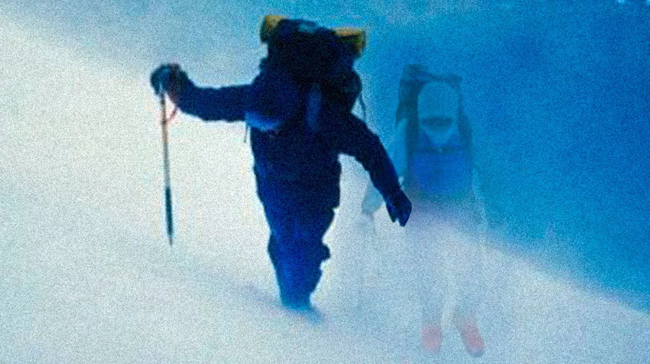

We have talked about the third man theory or syndrome before, in one of our very first episodes, episodes 3 and 4 focusing on Ernest Shackleton’s Endurance expedition in 1914-1916. This was the first story of “the third man” to really be published to the general public. Disaster first struck for the expedition when their ship, the Endurance, was frozen fast in the Weddell sea. They were carried on the ice for 10 months after the ship was abandoned in 1915 due to it being crushed in the sea ice. The crew was forced to make a harrowing retreat to the isolated Elephant island which left many of the men in bad shape, with dysentery, salt sores, and frostbite. They were fifteen months into the ordeal.

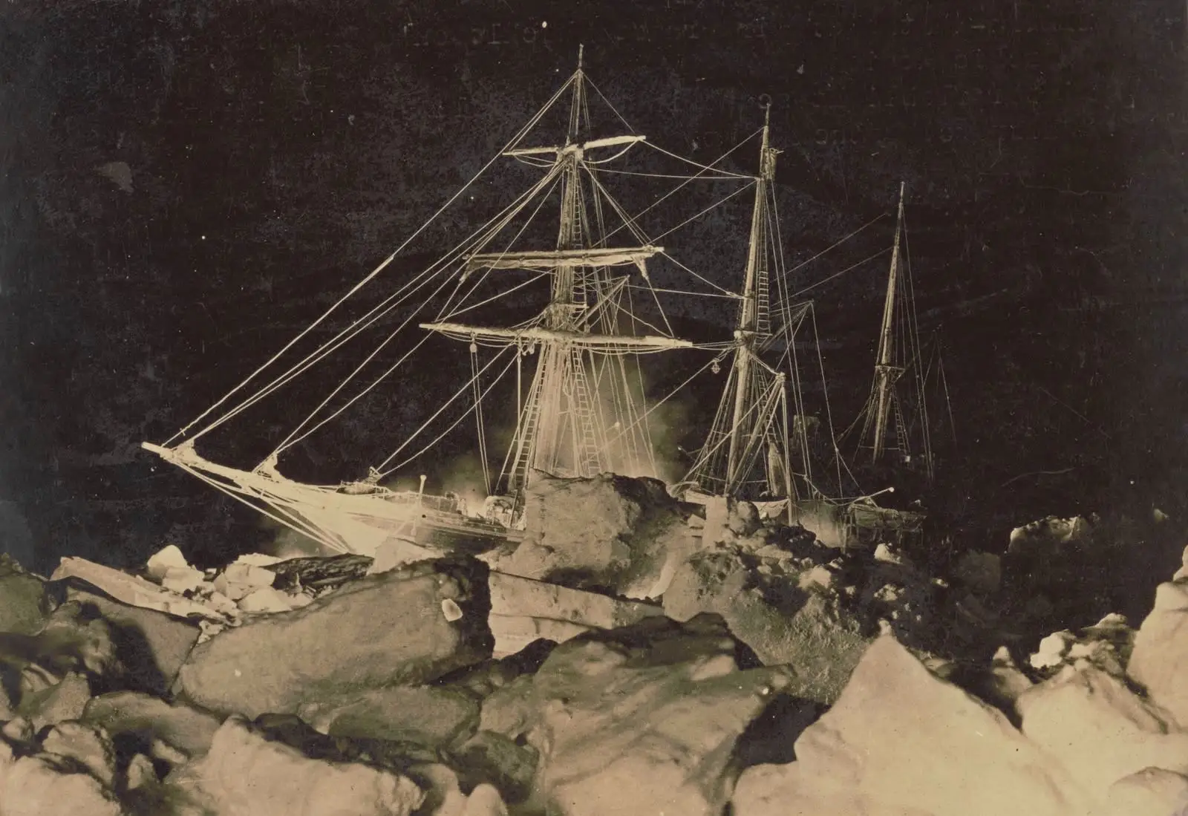The Endurance frozen in ice, https://www.sciencefriday.com/segments/shackleton-endurance-beneath-the-ice-book/

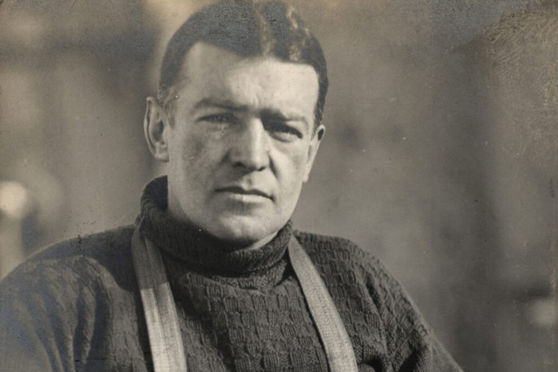
Ernest Shackleton, https://www.historyextra.com/period/20th-century/ernest-shackleton-great-antarctic-explorer-who-life-death/

Shackleton knew there was not a chance that a relief expedition would find them, so he took five other men in a modified whale boat across some of the most dangerous seas on the planet to reach a whaling station on South Georgia Island to get help for the rest of the men on Elephant Island. The whaling station was more than 680 miles away, and the six men endured massive gales and heavy seas for seventeen days, and were sea sick, frostbit, soaked basically the entire time. Sea ice would form on the boat, constantly threatening to capsize the little vessel. They were forced to sleep on the ballast, which was rocks from the island, in damp sleeping bags. One keg of drinking water had gotten lost in some massive swells, and so they started becoming severely dehydrated Somehow, through an amazing feat of their navigator, they managed to reach South Georgia – the problem was, they were on the other side of the island, opposite of where the whaling station was. Currents and wind made it impossible (or near impossible) to sail around the island, so Shackleton decided that their best bet was to cross the island. South Georgia Island has an extremely mountainous interior, covered by two mountain ranges with a dozen peaks exceeding sixty-five hundred feet, surrounded by dangerous ice fields and glacier, and it was standing in the way of the men’s rescue.

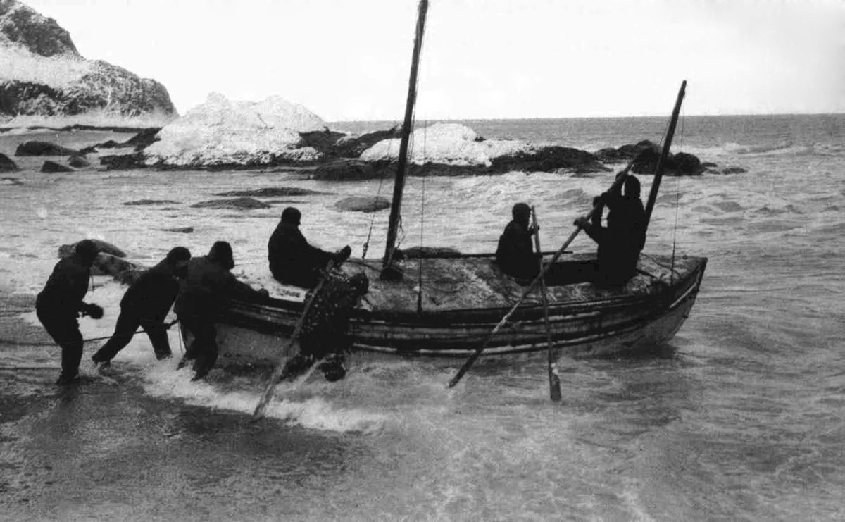
The six men and the James Caird, the boat they took to South Georgia, Wikipedia

On 3 AM on May 19th, 1916, Ernest Shackleton, Fred Worsley, and Tom Crean, set out, leaving their other three companions in the relative shelter of a cave, set out to cross the island. They had basically no mountaineering gear, next to no food, and had extremely worn out cold weather gear, but they knew they were the expedition’s only hope at this point. They had only fifteen yards of rope and a pick ax. They forced their way forward, around crevasses, crossing snowfields, climbing ridges, through the night, through fog, with virtually no sleep and very little food. Once, when confronting a dangerous slope, they opted to just slide down the slope like penguins. They walked essentially without sleep until the 20th when they heard what they thought was a steam whistle, likely from the whaling station. They marched on into the station, barely recognizable as human, but they had done the impossible. All of the men on the expedition were rescued and survived.

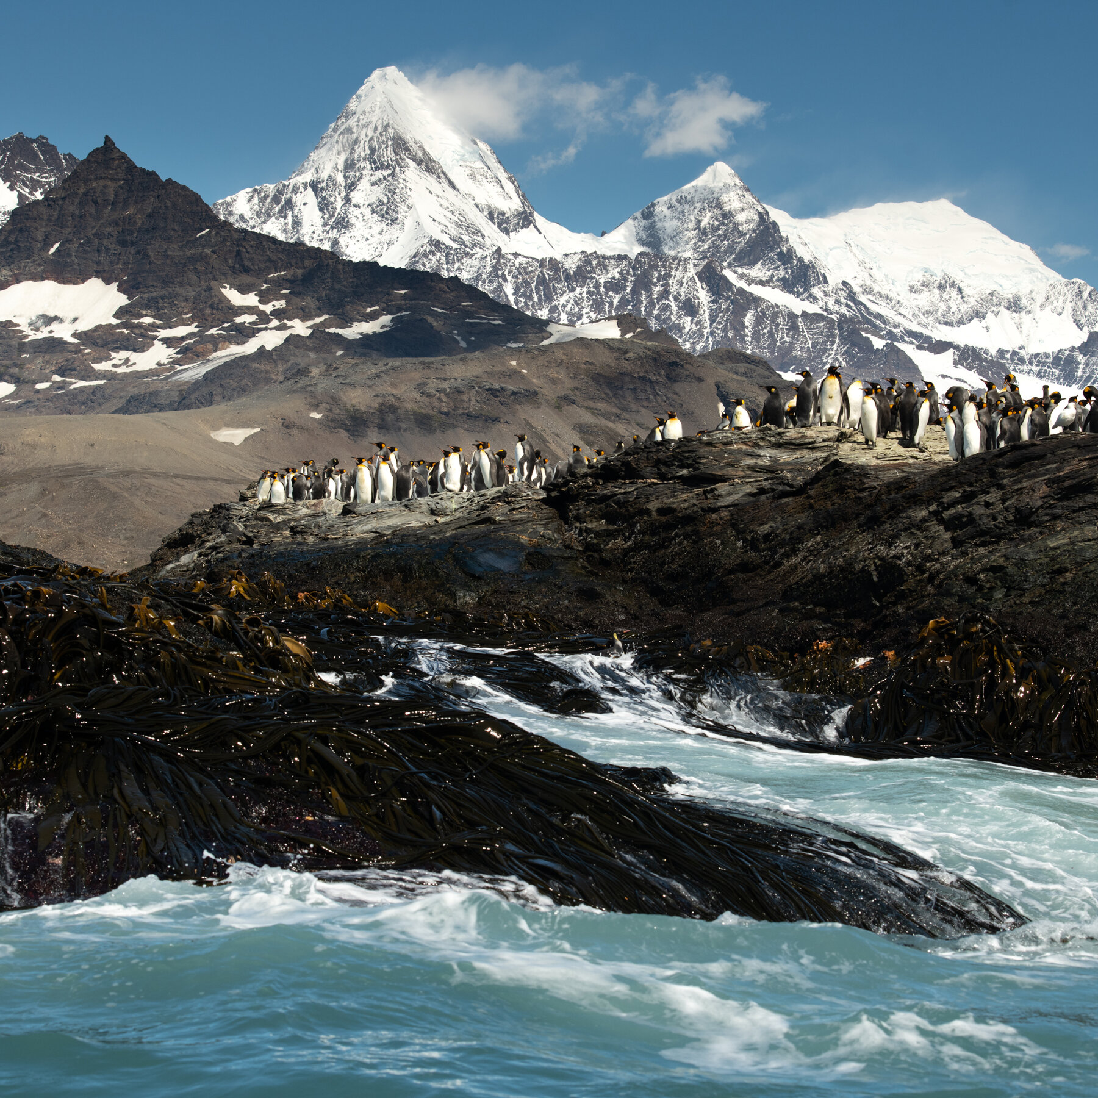
The rugged mountains of South Georgia Island, https://www.nytimes.com/2022/04/18/travel/south-georgia-island-recovery.html

It was unknown how the three men, who were likely close to death themselves, managed to cross South Georgia, which was not successfully cross again until the 1950s by a professional climber expedition. It wasn’t until later that Shackleton revealed something they all experienced. He confided in his friend after returning to New Zealand that while crossing those mountains, he felt a fourth man was walking with them. He had not mentioned it to the others. In his retelling of the adventure in his recounting of the expedition, South, he stated “When I look back at those days I have no doubt that Providence guided us, not only across those snow fields, but across the storm-white sea that separated Elephant Island from our landing place on South Georgia. I know that during that long and racking march of thirty-six hours over the unnamed mountains and glaciers of South Georgia it seemed to me often that we were four, not three.” Worsley also mentioned, three weeks later without prompting, “Boss, I had a curious feeling on the march that there was another person with us,” and Crean also confessed the same sensation of being with another being.

At first, Shackleton and the others did not want to talk about what they had experienced as they felt it made them seem silly, and they were embarrassed, however, eventually, the story of the fourth man was published, and it caught the public’s fascination. It was later called “the third man” instead of the fourth due to the T.S. Elliot poem inspired by Shackleton’s ordeal, called The Waste Land

Who is the third who walks always beside you?
When I count, there are only you and I together
But when I look up ahead up the white road
There is always another one walking beside you.

The Third Man Syndrome is described as a “Sensed presence” or a “vivid physical awareness” of an “illusory shadow person”, usually considered benevolent, and usually under stressful circumstances. Many consider it a spiritual guide or a guardian angel (likely where the idea/phrase came from), however, there may be scientific reasons as to why the Third Man occurs, mostly lying with extreme situations and environments.

There are a lot of incidents that have produced a third man beyond polar exploration including famous pilot Charles Lindberg, who saw ghostly presences following along with his plane during a storm when he flew his first non-stop solo flight across the Atlantic. Shipwreck survivors and prisoners of war also have reported having third man encounters. There were two recorded instances of the third man on 9/11, including Will Jimeno, who survived being buried alive under concrete slabs when the South Tower went down. Ron DiFrancisco was another 9/11 survivor, who was on the 84 floor of the South Tower when the second plane struck below him. The third man led him down the flight of stairs, and he was able to escape before the tower collapsed. He was one of the only survivors from above the crash, and the last person to leave the building before it collapsed. Other than polar exploration, one of the most common places to see the third man is in alpine expeditions. Climber Frank Smythe and Eric Shipton attempted to summit Mt. Everest in 1933, with extreme difficulty that ultimately forced them to turn around. Smythe described experiencing a presence that felt so real that he attempted to share a “Kendal mint cake” (a common hiking ration) with his felt companion. Another explorer we have talked about, Yossi Ghinsberg, had his own third man experience. While stranded alone in the Amazon, he felt the presence of a young indigenous woman. He took care of her for several days before she disappeared. Eventually, he managed to be rescued.

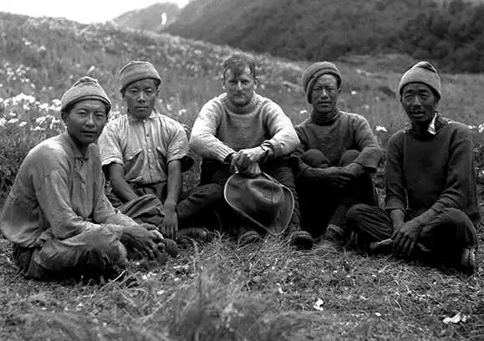
Everest pioneer Frank Smythe, https://www.markhorrell.com/blog/2020/his-father-frank-smythe-biography-of-a-himalayan-legend/

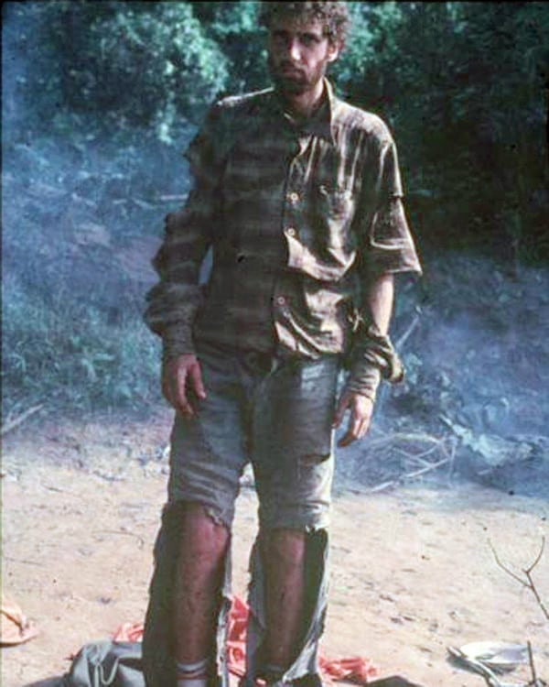
Yossi Ghinsberg, https://www.reddit.com/r/HistoryPorn/comments/10qmpjr/yossi_ghinsberg_the_day_he_was_found_having_been/

Encounters with the third man are more prevalent today than at any point in history because far more people are engaged in journeys of endurance in extreme and usual environments than ever before (EUEs). Why do we push ourselves into these environments? Its thought that humans seek alternate environments to escape the monotony of the one they are currently in, which is part of the reason why we have set off to explore the globe. Geiger writes in the book, “Some contempt for body comfort, and a need for stimuli derived from risky activities, are part of everybody’s makeup” The ventral striatum is a primitive part of the brain that has a role in making people adventurous. Novel stimuli makes ventral striatum more active, and is involved in processing rewards, which indicates that seeking new and novel experiences results in a release of dopamine.

There are several aspects which seem to (but not always) promote Third Man encounters:
- Monotony of landscape/Boredom
  - Monotony of landscape often promotes the human brain to hallucinate, as it seeks to create images when it has nothing it look at
  - Many of these environments are considered EUEs - lumped into three broad categories; 1) environments in which survival depends on advanced technology (space, deep ocean, open ocean, Antarctica, the sky), 2) environments that require special equipment but can be considered natural habitat for some human groups (the Arctic, mountains, deserts), and 3) habitats transformed by disaster (earthquake, hurricanes, war, even events such as 9/11)
  - Monotonous environments can result in hallucinations, as are often experienced by pilots and long road truckers.
  - In studies that removed stimuli (from all five senses), human subjects would create their own, by talking to themselves or singing, and reported experiencing a disturbance of the body image, feeling as if their body was not their own, or reported experiencing a second body next to theirs
    - This is clearly a potential source for some third man hallucinations
  - “Ghosts” are often potentially a side effect of this - The transglobe expedition to Antarctica in 1980 experienced this effect
    - Ginny Fiennes, the radio operator, experienced hearing footsteps and was convinced that something was in the radio hut with her
    - They were currently going through polar winter, in which strong winds and absolute darkness plagued them - creating a fairly featureless environment
    - The ghost dissipated once polar spring came, and the monotony of the environment changed.
- Physical stress (starvation, thirst, altitude, cold, heat, sleep deprivation)

Physical stress is an ordinary aspect of polar exploration, which makes the polar regions of the world prime for third man experiences. In fact, three individuals, several decades apart, all experienced the third man on their expeditions across the white continent of Antarctica. Robert Swan (GB), Peter Hillary (NZ), and Ann Bancroft (USA) all crossed the continent for various reasons, and all had their own third man experiences. Robert Swan was retracing Robert Falcon Scott’s South Pole attempt with two others in 1985, and had been dragging sledges for nine hours a day, seven days a week, in the numbing cold. He was exhausted and was struggling with facing another 560 miles of sledging to the sou0th pole, which had been his goal for 15 years. While hitting his lowest moment, he experienced something strange. He became convinced that there were three men ahead of him instead of two. Swan soon finally arrived at the point where he could not continue, and stopped and sat down on his sledge, and realized that the third man was now sitting beside him. He thought that the third man might be Robert Falcon Scott. The third man began laughing, and so, laughing being contagious, he began laughing too. He stated the moment was comforting. When his teammates returned to find him, he was in much better spirits, stating “Well, this is really quite bizarre!” Before setting off, the others inspected the sledge, finding that the sledge runners had been mounted incorrectly, and repaired them, making it much easier for Swan to pull the sledge and continue on. The three men reached the south pole on Jan 11, 1986 after traveling 883 miles, setting a record of the longest unassisted Antarctic march. A few years later, Swan also reached the north pole, becoming the first man in history to walk unsupported to both the North and South Poles.

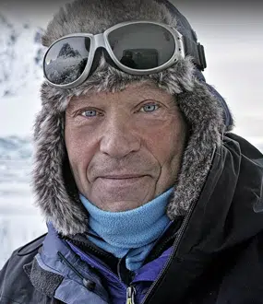 Robert Swan, https://speaking.com/speakers/robert-swan/

Peter Hillary was the son of the great Sir Edmund Hillary, the first man to summit Everest, and he too, with two others in 1998, hoped to complete Robert Falcon Scott’s last journey. They set off from Scott Base pulling 440 lbs each on sledges, hauling them across the Ross Ice Shelf and up the Shackleton Glacier and Polar Plateau. The round trip would total 1,800 miles. Conditions were brutal with intense cold, relentless winds, and they were slowly starving, as they were burning more calories pulling the sledges than they could replenish. Furthermore, Hillary began to feel that the others were resentful of him, or talking about him behind his back, excluding him from social interaction - Hillary’s response was to pull back, allowing the others to go ahead, furthering his isolation. He described the Ross Ice Shelf as a “monochrome of misery…everything was white, and my mind had nothing to read: nothing was coming in, because everything was white…with nothing coming in, I believe now everything comes out of you, everything leached out of you like salt is leached from soil by fresh water.” On the eighteenth day, he became aware of a presence close by him and recognized it as his mother who had died in an airplane crash in Kathmandu in 1975. It went beyond a living memory “It was like she’d come out there to keep me company. It was like she was really there. Right there. In a way that was almost scary. Yet it seemed natural as anything to walk along talking to her.” The presence left him in the early afternoon, and returned and remained with him in the evening. The tension among the men continued, likely due to the fact that the others thought Hillary was slowing them down as he was struggling for days with one of his boots. The presence would appear intermittently throughout the week. The men finally made up, apologizing to Hillary, and tension resolved, however, on day 36, Hillary experienced many presences in the tent, he recognized two as his climbing friends who had died. On day 39, the three experienced a blizzard which left them tent bound, dwindling their food resources. At this point, they decided to abandoned their return journey and fly home from the South Pole instead. Hillary stated, “If we’d done the (return) trip in the Captain’s day, there would have been another tent out there with three people lying (dead) in it.” Just before reaching the South Pole Station, he experienced one last visit from his mother and his two climbing friends.
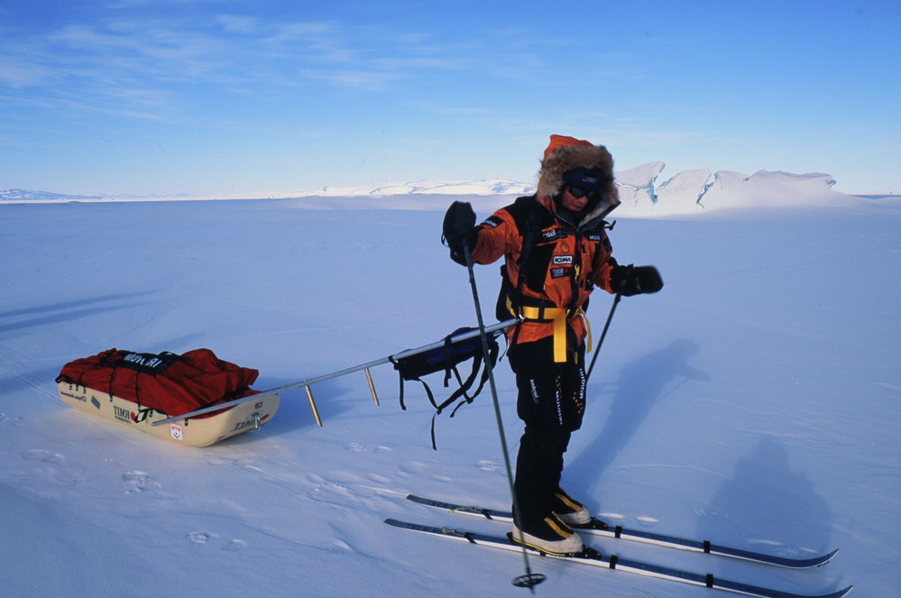
Peter Hillary, https://adam.antarcticanz.govt.nz/nodes/view/25212

Ann Bancroft was an American explorer hoping to cover more than 1,900 miles across the remote Queen Maud Land to McMurdo Station in 2000. The crossing of Antarctica with her fellow explorer, Norwegian Liv Arnesen would make them the first women to accomplish this feat and would set a distance record. The terrain was particularly difficult, they were both hauling 250 lbs, and it was snowing heavily They needed to travel the rate of twenty miles a day on skis, aided by sails - but from the outset they were behind pace. Temperature was fairly constant at -30oF. Bancroft also suffered a muscle strain when one blast of wind tore her arm outward as she struggled to untangle a tow line.
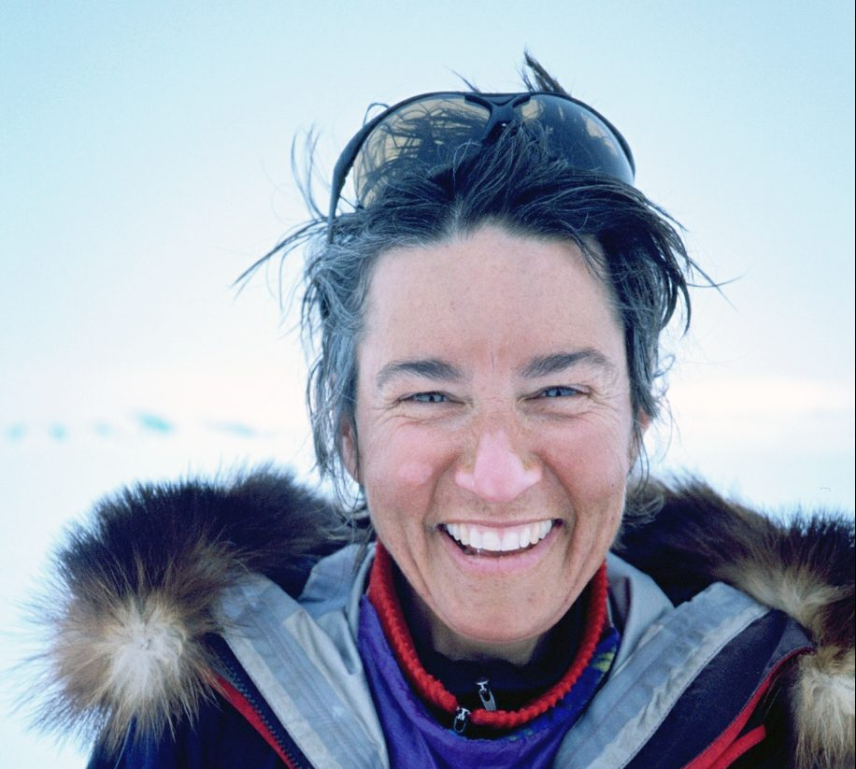
Ann Bancroft, https://news.stthomas.edu/polar-explorer-environmentalist-ann-bancroft-presents-no-horozon-is-so-far/

At some point only a few weeks into the journey, Bancroft experienced the abrupt sense of being very close company with another person. She stated, “It startled me, because there was a flood of emotion with it, because it was so strong, and almost unmistakable, and it was good medicine, it was what I needed. It worked, whatever it was…a strong feeling of my mentor (who had passed away not too long ago) filled the area. It was a presence of egging me or encouraging me along.” The third person in this case was her grandmother Rannnie. The sense of the presence persisted for some time “It hung around for a while to the point where–it feels a little bit silly to say–to the point of actually saying something, speaking out loud to this presence.” The presence was initially very strong, then lingered on a lower background level for the rest of the day and night. Bancroft felt that it gave her the motivation to work through the pain of her injury, and to acknowledge that she could get through this journey, even though it would be extremely difficult. Bancroft and Arnesen ultimately triumphed, becoming the first women to cross the continent.

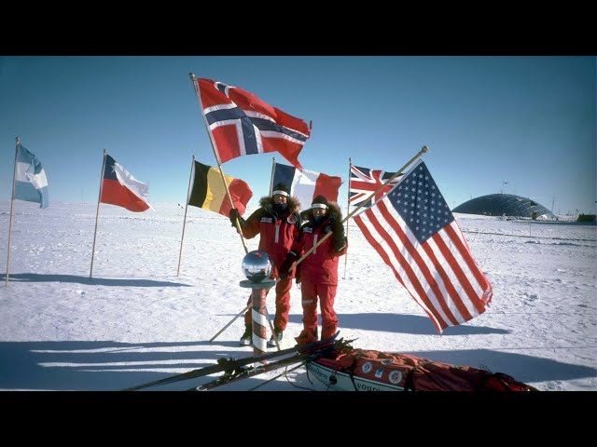
Bancroft and Arnesen triumph https://www.youtube.com/watch?v=JmJ4rG0YyZQ&themeRefresh=1

For each person, triggering the third man occurred when the baseline of monotony and isolation was combined with some other stress or combination of stresses, and there is some scientific theory to back this up. Dr. Evan Llewelyn Lloyd stated that “cold stress, sometimes alone but often accompanied by fatigue, are common factors in all these case reports… cold stress induced hallucinations are not uncommon once the core body temperature drops and are occasionally reported by individuals exercising in the cold as well. Cold stress can cause neurochemical changes and hallucinations “may also occur as a form of self-hypnosis in response to a situation involving extreme discomfort.” Fiona Godlee writing for the British Medical Journal in 1993 stated specifically of Shackleton’s party that they had “blood glucose concentrations almost incompatible with life.” as they were on a starvation diet, which can lead to “a mixing of reality and imagination experienced by many polar explorers…Shackleton and his team were aware of a so called ‘third man’, a comforting presence seen by some of them, who they looked on as their guardian. Peter Suedfield and Jane Mocellin in a 1987 published study argued that stress is produced when boredom and monotony is combined with a need to maintain a high level of alertness. Fun Fact: Research even indicates that hallucinatory presences felt during sleep paralysis episodes may be similar neurologically to third man events

Ultimately, the third man is potentially a combination of effects, likely set off by multiple triggers, a combination of monotony of environment and extreme physical stress, however, there may be another reason for the third man. The third man may be a survival mechanism created by our brains to keep a person alive in a dire situation. This theory was put forward by Swiss neuroscience Peter Brugger in 1996, which basically stated that the mind produces this person a phantom double, or a doppelganger, similar to a phantom limb. Brugger describes this as “An extension of one’s own corporeal awareness into extracorporeal space.”, or in other words, the brain externalizes own-body awareness then detects the false sense of another being nearby. Brugger’s theory was that, many people with third man experiences try to take care of the third man (like the mountaineer that tried to share food with his third man, or Yossi Ghinsberg and his native woman) and motivates them to carry on as they have someone else to focus on. Brugger suggests that in such cases, people are actually caring not for the third man but for themselves.

Geiger - The Third Man has been called many things: a sensory illusion or hallucination caused by extreme physical exertion or monotony; a medical condition attributable to low blood glucose, high-altitude cerebral edema, or cold stress; a ghostly apparition or mediumistic experience; a manifestation of a guardian angel; or a psychological “compensatory figure” that embodies “inner resources that the beleaguered person is not able to call on in the ordinary way.” It’s possible that every person has this ability to produce the third man, and it takes an extreme situation to trigger the third man, and it may be a survival mechanism built in to keep us motivated, to keep us moving forward, and to keep us alive. However, one of the strangest things about this phenomenon is that it can be shared, at the the same time, between several people undergoing the same experienced, as shown by Shackleton and his two men on South Georgia Island. While there are some suggested arguments to why this may be happening in tandem, it is still one of the stranger phenomenons related to the third man syndrome and is one that has yet to be fully explained by science. Whether or not the third man is a guardian angel or a deep rooted survival mechanism that allows our brains to trick us into carrying on, it is one of the stranger mysteries that those who explore the far reaches of our world can experience.

