Episode 85 - The Sinking of the U.S.S. Indianapolis

The Worst Shark Attack in History, Natasha Geiling, Smithsonian Magazine https://www.smithsonianmag.com/history/the-worst-shark-attack-in-history-25715092/

Surviving the Sinking of the USS Indianapolis, Seth Paridon, The National WWII Museum https://www.nationalww2museum.org/war/articles/surviving-sinking-uss-indianapolis

USS Indianapolis sinking: “You could see sharks circling”, Alex Last, BBC https://www.bbc.com/news/magazine-23455951

USS Indianapolis (CA-35) https://en.wikipedia.org/wiki/USS_Indianapolis_(CA-35)

Oceanic Whitetip Shark, Carcharhinus longimanus, Cathleen Bester, Florida Musuem https://www.floridamuseum.ufl.edu/discover-fish/species-profiles/carcharhinus-longimanus/

The Truth About Oceanic Whitetip Sharks, Katie Hogge, The Ocean Conservancy https://oceanconservancy.org/blog/2023/06/01/truth-about-oceanic-whitetip-sharks/

The USS Indianapolis was a CA-35 heavy cruiser that was a major player in the Pacific Theater in WWII, and unfortunately, was part of one of the worst maritime disasters in U.S. Naval history. Known as the “Indy” by the crew, it was one of the older vessels in the Pacific fleet, however, that did not stop it from taking part in numerous battles. The Indianapolis was a portland-class heavy cruiser and entered WWII when Japan attacked pearl harbor - it was one of the vessels that searched for the Japanese carriers responsible for the attack. She was then part of Task Force 11 and entered the New Guinea campaign in 1941 and the Aleutian Island Campaign from 1942-43. In 1943-44 she returned to Hawaii to become the flagship of Vice Admiral Raymond A. Spruance, where she was part of several major battles in the south Pacific, including and the Battle of Makin, the Battle of Tarawa, the Battle of the PHilippine Sea, and served as a support vessel during the landings on Iwo Jima and provided major supporting fire during the invasion of Okinawa. Most importantly, around the time of the sinking, the indianapolis had delivered crucial components of the first operational atomic bomb, a bomb that would level Hiroshima on August 6th, 1945. These parts were required for the assembly of the bomb code named “Little Boy”, which would become the first atomic bomb dropped in warfare. Before that world changing event, however, the Indianapolis would undergo it’s own horrific ordeal, an ordeal that would marr the U.S. Navy in the decades following.

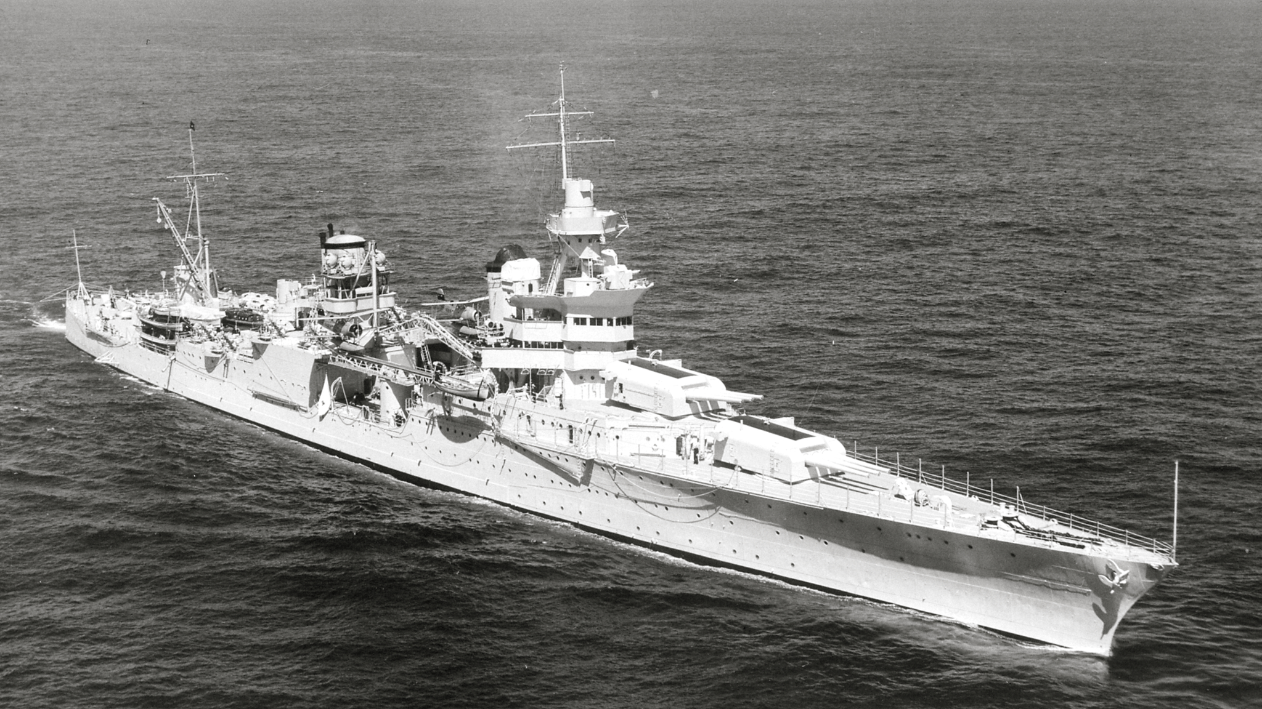
USS Indianapolis, Wikipedia

On the 28th of July, the Indianapolis was sailing for Guam to meet the battleship USS Idaho in the Leyte Gulf in the Philippines to prepare for the invasion of Japan. On the 29th, the Indianapolis was making 17 knots towards its destination, and all was quiet on board as sailors played cards and read books. Shortly after midnight, a Japanese torpedo hit the starboard bow, blowing almost 65 ft of the ship’s bow out of the water. 19-year-old seaman, Loel Dean Cox, was on duty on the bridge, and recalls the moment the torpedo hit, “Whoom. Up in the air I went. There was water, debris, fire, everything just coming up and we were 81ft from the waterline. It was a tremendous explosion. Then, about the time I got to my knees, another one hit. Whoom.” It also ignited a tank containing 3,500 gallons of aviation fuel, causing a pillar of fire to shoot several hundred feet into the sky. Another torpedo hit closer to mid ship, setting off a chain reaction of explosions from fuel tanks and powder magazines that ripped the Indianapolis in two. Massachusetts native and new Naval Academy graduate, Ensign Harlan Twible, was one of the survivors of the ordeal, stating, “We knew we were in trouble, so I took command and I told them to hang onto anything they could hang onto…then when the tilt became too great, I gave the order to abandon ship. Nobody abandoned, then I yelled, ‘Follow me!” and the bodies came in so fast it was unbelievable”

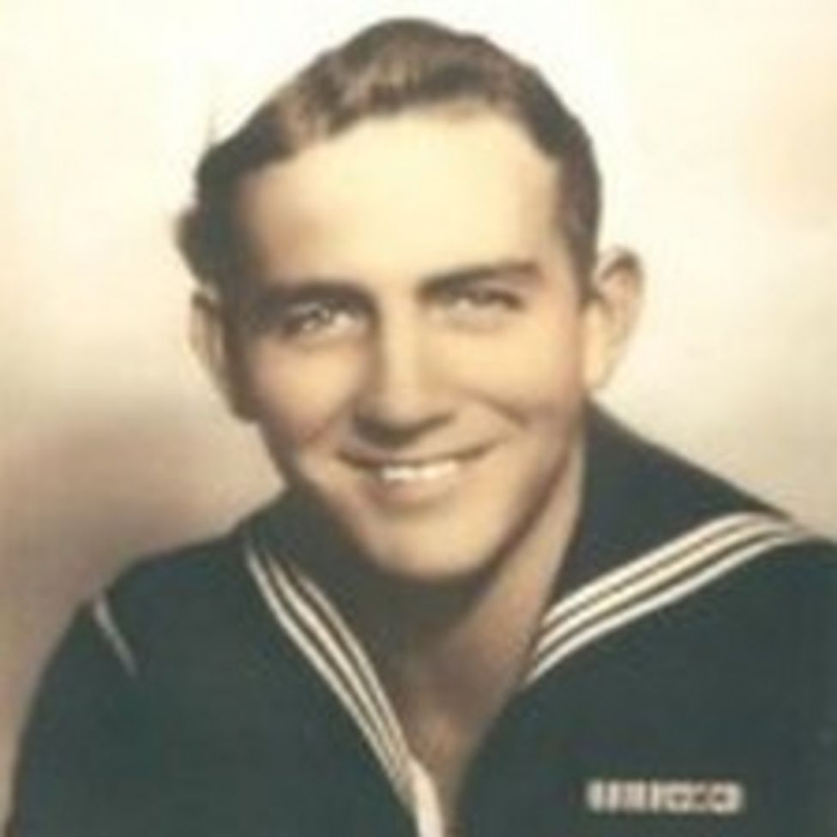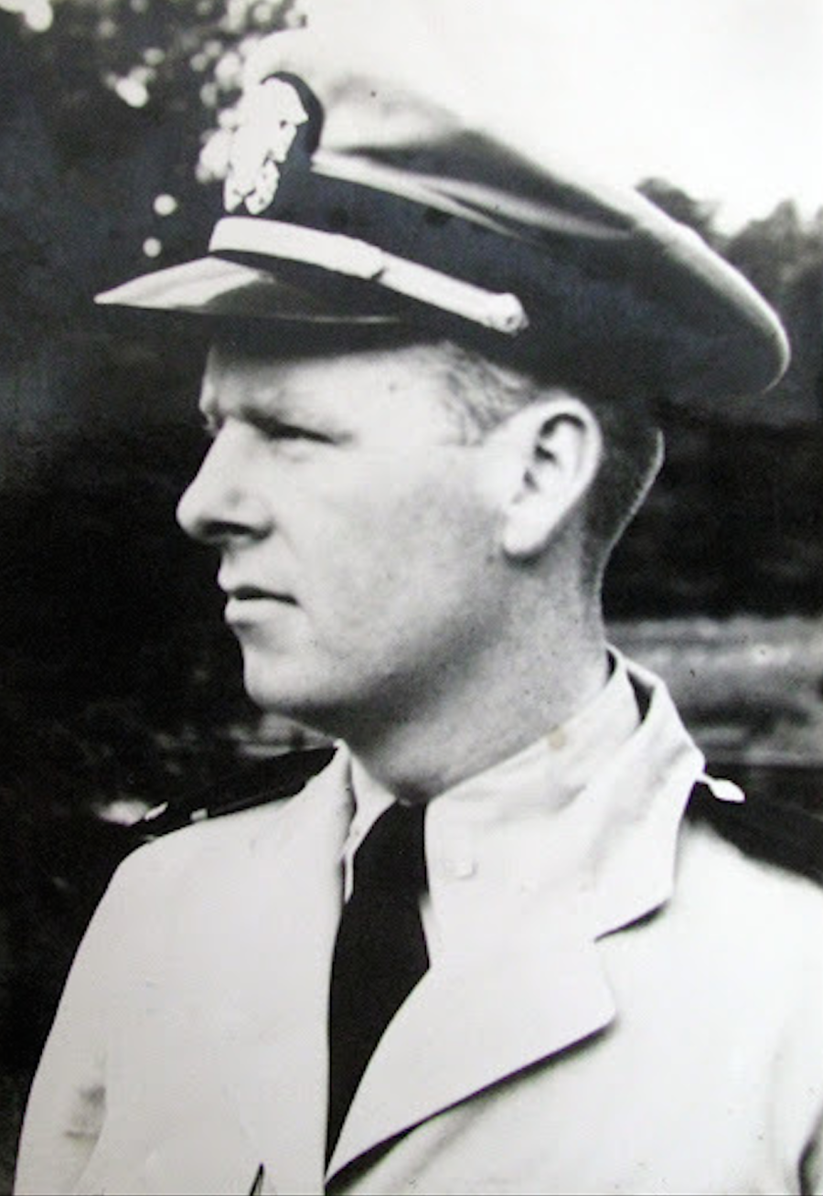
Loel Dean Cox, BBC Ensign Harlan Twible, https://donmooreswartales.com/2012/05/30/harlan-twible/

The ship was still traveling at 17 knots, and began taking on huge amounts of water, sinking in only 12 minutes. Cox stated of the experience, “Twelve minutes. Can you imagine a ship 610 ft long that’s two football fields in length, sinking in 12 minutes? It just rolled over and went under.” Unfortunately the Indianapolis did not have the sonar to detect submarines, and the escort request had been turned down. In addition, the U.S. Navy had failed to pass the info that Japanese submarines were still active in the area. The Indianapolis was all alone when it sank.

Of the 1,196 men on board, a miraculous 900 made it into the water alive, but their ordeal was just beginning, and the death toll would rise in the coming days. When the sun rose on July 30th, hundreds of survivors were floating in the open water, and there were almost no life rafts available. Cox stated upon seeing the sun that morning, “I never saw a life raft. I finally heard some moans and groans and yelling and swam over and got with a group of 30 men and that’s where I stayed. We figured that if we could just hold out for a couple of days they’d pick us up.” Many survivors began searching the dead, grabbing their life jackets for survivors who didn’t have any. Ensign Twible, and many others, were wounded from the torpedo attacks, stating “Everybody was scared to death. These were all 18-and 19-year-old kids. There wasn’t any fighting, any turmoil, but everybody was scared.” The survivors began to form groups, some smaller, some up to 300 men. As the sun rose, Twible did a headcount and realized he was the only officer in charge of the three hundred survivors in his group. From here they would begin the real fight for survival as they awaited rescue–starving off exposure, thirst, and sharks.

The first night, sharks were drawn into the site of the sinking, likely due to the sound of the explosions, the thrashing of survivors in the water, and the blood from both the dead and and the survivors. Cox stated of the initial attacks, “We were sunk at midnight, I saw one the first morning after daylight. They were big. Some of them I swear were 15 feet long. They were continually there, mostly feeding off the dead bodies. Thank goodness, there were lots of dead people floating in the area.” Sharks can feel motion from hundreds of feet away through their lateral line, which are receptors along their bodies that pick up changes in pressure and movements. The first night, the sharks fed off of the floating dead, but the struggling survivors in the water only attracted more sharks. It’s thought that, due to the surface based nature of their hunting, and the fact that the ship sunk in open, pelagic water, that a majority of the sharks in the area were oceanic whitetips.

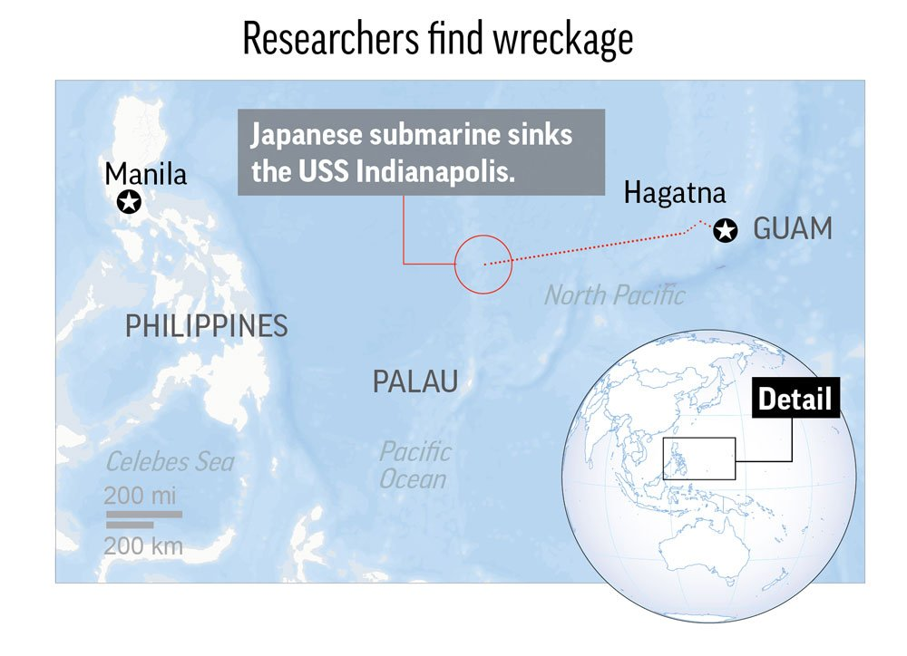
Approximate location of the sinking, https://apnews.com/article/7fa07373dcc948c498e5fe8627dfb989

Soon the sharks turned their attention to the living, particularly those injured and bleeding. The groups of sailors would try to quarantine themselves away from anyone with an open wound, and if someone died, they would push the corpse away to hopefully lure the sharks away from the living. Survivors were hesitant to eat or drink from the limited rations they had managed to salvage from the ship – one group opened a can of spam, but before they could eat it, the scent had drawn a swarm of sharks around them. They got rid of their meat rations. Slowly but surely, the men realized that their best odds were in a group, ideally in the center of a group - those at the margins, or worse, alone, were the most susceptible to the sharks. The sharks would usually stay away from the larger groups who would beat and kick the sharks, usually forcing them away. Twible organized “shark watches” to keep the men together and to fend off the sharks as they came in. “We were losing three or four each night and day. You were constantly in fear because you’d see ‘em all the time. Every few minutes you’d see their fins - a dozen to two dozen fins in the water. They would come up and bump you. I was bumped a few times - you never know when they are going to attack you,” Cox stated, “In that clear water you could see the sharks circling. Then every now and then, like lightning, one would come straight up and take a sailor and take them straight down. One came up and took the sailor next to me. It was just somebody screaming, yelling or getting bit.” 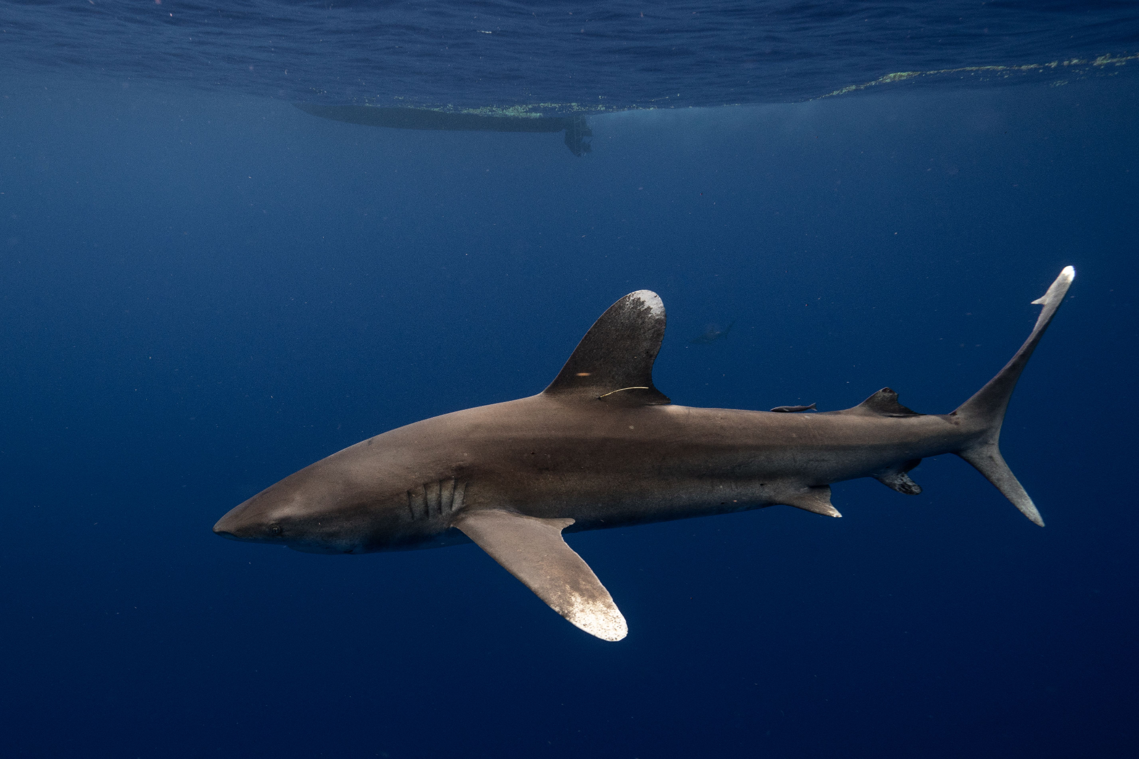
Oceanic Whitetip Shark, NOAA fisheries

Oceanic Whitetip Sharks (Carcharhinus longimanus) are large, pelagic sharks with distinctive long white-tipped paddle like pectoral fins and rounded first dorsal fin. They can grow to large sizes, with some individuals reaching 11-13 ft in length. Males and females mature at similar sizes at about 4-5 years old, and have a 10-12 month gestation period, and 1-15 pups are born, according to the animals size Apparently they also have some unique courtship behaviors, including parallel swimming, biting, and nosing. They are usually solitary and slow moving, preferring the upper layers of pelagic ocean, and are opportunistic hunters, making them ideal to attack shipwreck and plane crash survivors. They do form aggregations and have been observed in “feeding frenzies” when a food sources is present (i.e. bait balls). Feeding behavior includes biting into schools of bony fishes, and since whitetips spend so much time moving through open water, meals can be few and far between, so they will take a shot at any food they can get. While the oceanic whitetip is a slow swimmer, they are one of the species of shark that cannot pump water over their gills and must consistently move to breathe. They mostly feed on bony fishes including barracuda, jacks, mahi, marlin, and tuna, but will also eat other animals, including squid, sea turtles, and sea birds, and have been observed eating garbage. Remoras, dolphinfishes, and pilot fishes often accompany whitetip sharks, and whitetips have been reported swimming in association with Pilot Whales, thought to be following them to food resources.

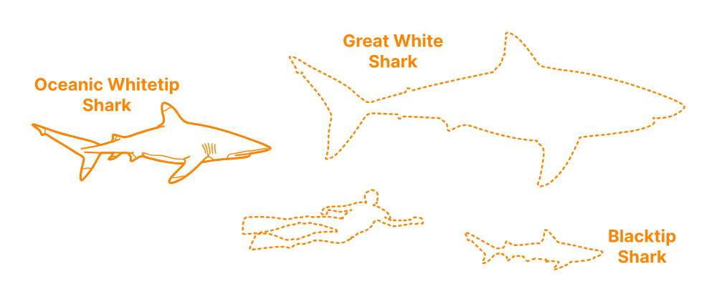
Size comparisons of whitetips to humans and other sharks species

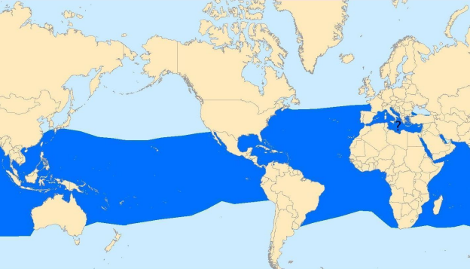
Whitetip shark range, NOAA fisheries

They range worldwide in epipelagic (surface water) tropical and subtropical waters, but are usually observed well offshore in deep water areas - it is very unlikely to see them in coastal areas. They were once considered one of the top three most abundant oceanic sharks (including silky and blue sharks), but are now only occasionally reported, though still one of the most widespread of all shark species. Due to their hunting style and feeding nature, they are one of the more dangerous sharks to humans - before the sinking of the Indianapolis, they were known to attack survivors of ship and plane wrecks at sea, and are often the first species seen in waters surrounding mid-ocean disasters. During both world wars, these sharks were a major concern for torpedoed boats and downed planes. In encounters with divers, oceanic whitetip sharks show little fear of humans and persistent circling behavior. While they have killed a fair number of humans, humans, by far, have killed much greater numbers of oceanic whitetips. They are in the IUCN red list with a vulnerable status, as they have suffered sharp declines from historic levels due to being caught as bycatch in tuna longline fisheries and due to direct targeting for their fins which are highly prized in the Asian Fin Trade. Their meat is marketed for human consumption, skin used for leather, fins for shark fin soup and liver oil for vitamins.

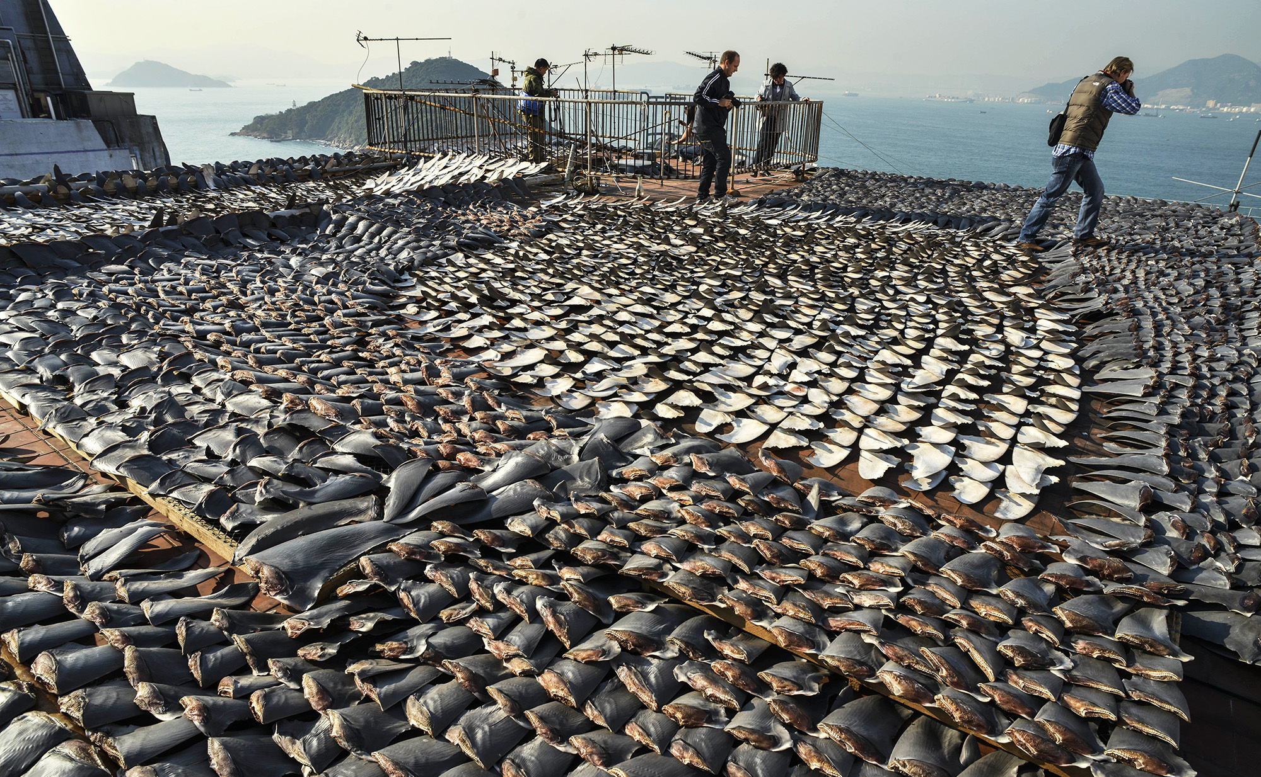
The Shark finning industry, NPR

The plight of the oceanic whitetip was not on the forefront of the minds of the survivors of the Indianapolis’s sinking. The men continued to float for days, and the sharks continued to feed, and rescue seemed dire. In the meantime, Navy intelligence had intercepted a message from the Japanese Submarine that had sunk the Indianapolis - the message stated that the submarine had torpedoed an American battleship along the Indianapolis’s route. Unfortunately, the message was disregarded as a trick to lure American rescue boats into an ambush. The Navy had no idea that there were hundreds of American sailors floating in the water, trying to stave off the worst shark attack in history. But this was not all, as the Indianapolis had sent several SOS signals before it sank, but the messages were not taken seriously by the Navy, and not much notice was taken when the ship failed to arrive on time. This lack of attention from the Navy made this disaster so much worse than it could have been had the Navy acted on the first warning signs. This incompetence has followed this story in the decades after the disaster, making the sinking one of the more controversial disasters in Naval history as well.

What's more, the sharks were no longer the number one killer of the men as the days wore on. The longer the men were in the water, the more men died, succumbing to heat, thirst, or suffering from hallucinations compelling them to drink the seawater around them. The life jackets began getting waterlogged as well, and many became exhausted by trending water and drowned. Cox stated of the experience, “You could barely keep your face out of the water. The life preserver had blisters on my shoulders, blisters on top of blisters. It was so hot we would pray for dark, and when it got dark we would pray for daylight, because it would get so cold our teeth would chatter.” The men drinking seawater became bigger threats to the survivors than the sharks. This was a death sentence via salt poisoning, and those who drank seawater would foam at the mouth as their lips and tongues swelled. Many would drag their fellow survivors underwater as they died. Cox talked about a buddy of his, who was hallucinating that the Indianapolis was still there, “The drinking water was kept on the second deck of our ship. A buddy of mine was hallucinating and he decided he would go down to the second deck to get a drink of water. All of a sudden his life preserver is floating, but he’s not there. And then he comes up saying how good and cool that water was, and we should get us a drink.” His friend died shortly afterward, due to saltwater poisoning.

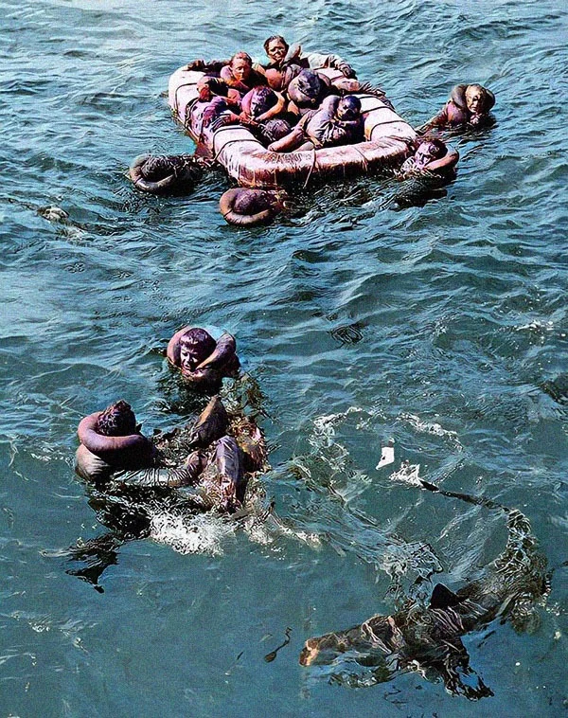
A colorized photo of the survivors still being circled by sharks, Wikipedia

On the fourth day, they were finally spotted by a Navy plane flying overhead at 11 AM, and called for help. Within a few hours, another seaplane returned to the scene and dropped rafts and survival supplies, but pilot Lieutenant Adrian Marks saw the men actively being attacked by the sharks, and so he disobeyed orders and landed to help the men. He began taxiing the plane to help the wounded and stragglers, to dissuade the sharks from nearing them. A little after midnight, the U.S.S. Doyle arrived on the scene and helped pull the last survivors from the water.

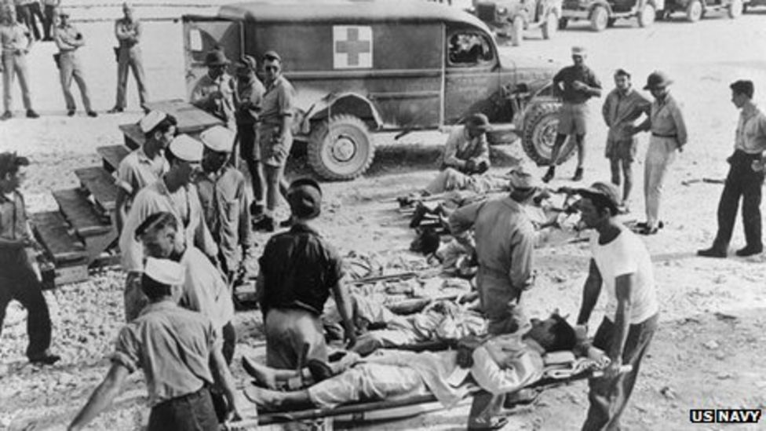
Survivors upon returning to shore

Of the original 1,196 man crew, only 317 survivors remained. It’s thought that the majority of those men died from thirst and exposure, however, estimates indicate that the number of those who died from shark attacks range from a few dozen to 150. The exact figure is unknown as there were many survivors who ever even saw a shark - it wasn’t the complete bloodbath that movies like to make it out to be. In addition, the sharks were more likely to grab those who floated away from the groups, which made the witnessing of many of the attacks less as these men were on their own.

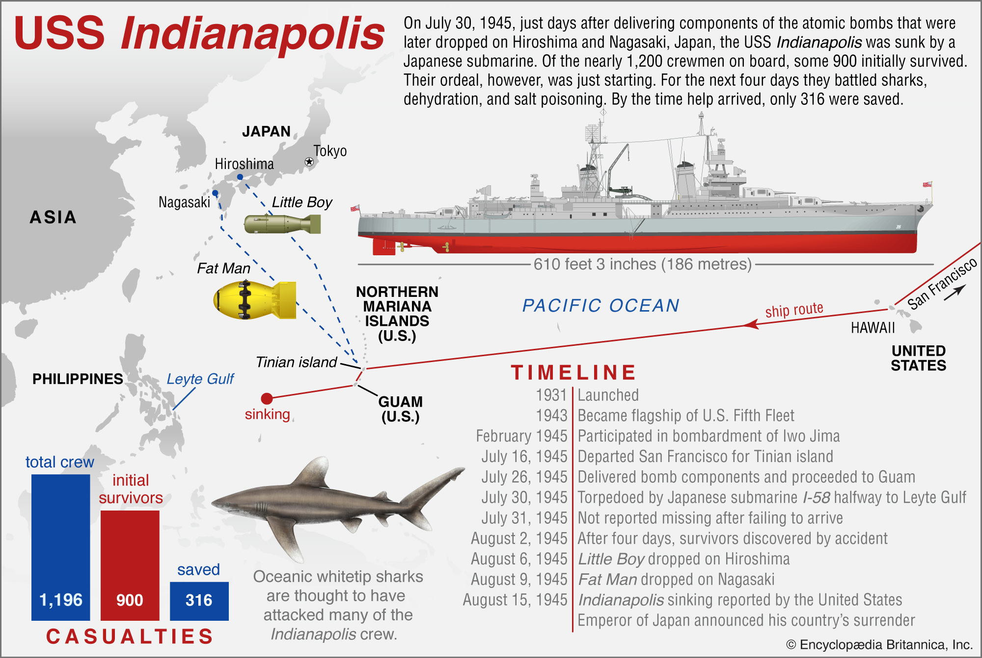

Not only was this one of the worst shark attacks in history, but it remains the worst maritime disaster in U.S. Naval history, and one of the most controversial. The U.S. Navy made a scapegoat out of the Captain of the Indianapolis, Captain McVay, who was among the few who managed to survive. He received hate mail for years and took his life in 1968, despite the fact that he had asked for a Naval escort due to the submarines in the area (a request which was denied), and had no responsibility in the sinking. For years following, the surviving crew campaigned for decades to have the captain exonerated, which he eventually was, more than 50 years after the sinking.

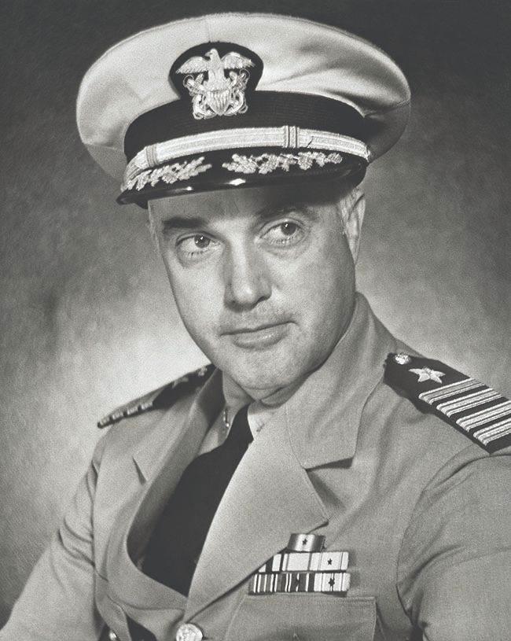
Captain Charles McVay, https://www.historynet.com/deep-sinking-uss-indianapolis/

Leon Cox spent weeks in the hospital - his hair, fingernails, and toenails came off, as he was “pickled” by the sun and the saltwater. He still has scars. Harlan Twible stayed in the Navy after WWII, serving through the Korean War and retiring in 1958 due to health issues due to his horrific survival ordeal in the Pacific Ocean. He became a successful businessman, retiring at the age of 54 and moving to Florida with his wife. For many years following the war he never talked about the disaster, but eventually, he felt that talking about the disaster helped people remember it and honors those who never made it out of the sea. He states of his legacy with the disaster, “What decision could I ever make that was anywhere near as important as the decision to tell those men to throw their lives into the water? That was one of the biggest decisions I ever made. I was gambling everybody’s life that we were gonna win.” Cox states of this experience in recurring nightmares, “I dream every night. It may not be in the water but…I am frantically trying to find my buddies. That’s part of the legacy. I have anxiety everyday, especially at night, but I’m living with it, sleeping with it, and getting by.”

