Episode 75 - Heroic Hawaiian Surfers

Life and Disappearance of Eddie Aikau

The surfing life story of Eddie Aikau, Surfing Today https://www.surfertoday.com/surfing/the-surfing-life-story-of-eddie-aikau

Examining The Death of Eddie Aikau (Eddie Would Go), Michael Woodsmall, The Inertia https://www.theinertia.com/disruptors/the-death-of-eddie-aikau-eddie-would-go/

Eddie Aikau: The Rad Life of a Hawaiian Surfing Legend, Lorraine Boissoneualt, JSTOR, https://daily.jstor.org/the-legend-of-eddie-aikau/

1978 Voyage to Tahiti Canceled After Hokule’a Capsizes, Hawaiian Voyaging Traditions https://archive.hokulea.com/holokai/1978/voyage_cancelled.html

Edward Ryon Makuahanai Aikau was born in Kahului, Maui, on May 4th 1946 as the second oldest of 5 Aikau kids and the leader of the group from the early days on Maui to their surfing days on the North Shore of Oahu. His brother, Clyde Aikau, talked about growing up with Eddie saying “Eddie was a pretty quiet guy, but when there was a challenge, or some risk to be taken, or a game to be played that everybody wanted to win, Eddie seemed to rise to the top. He was high risk at an early age.” He was hired at 16 as the first official lifeguard to work at Waimea Bay on Oahu’s North Shore in 1967, and at that time, challenged some of the biggest waves the Hawaiian Islands had to offer. He and his two brothers worked for 10 years until 1978 and never lost a single person, and this was before jet ski technology. He rescued and saved the lives of over 500 people during this period. His heroics and rescues lead to the motto among surfers “Eddie would go.”
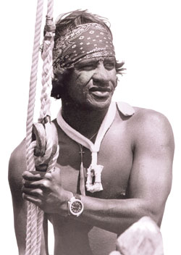
Eddie Aikau, Wikipedia

While he worked as a lifeguard on the north shore, he surfed every major swell and competed and won the 1977 Duke Kahanamoku Invitational Surfing Championship, though he made his mark in November 19th, 1967, riding a giant swell at Waimea bay, which remains the biggest day ever surfed at Waimea Bay. In the early to mid 1970s he traveled to South Africa, South America, and Australia to participate in early pro surfing events.

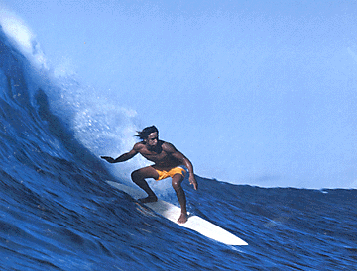
Eddie Aikau https://archive.hokulea.com/holokai/1978/voyage_cancelled.html

Eddie was a legend during a turbulent period of Hawaiian history that occurred about 20 years after Hawaii became an American state called the second Hawaiian Renaissance. During this time, native Hawaiians were determined to reclaim their heritage from a government that was encroaching on their communities and livelihoods. This came to a head when the International Professional Surfing (IPS) was founded in 1976 and created a circuit of professional surfing competitions. Before this, the North Shore was surfed primarily by local and native Hawaiians, but following this, the IPS held a number of competitions on the North Shore at popular spots like Pipeline and Sunset. The number of competitions jumped from 3 to 24 a year, forcing local surfers to stay away from their surf spots unless they were registered as competitors and given permits. It was seen by locals as a marginalization of native Hawaiians, and a group of 30 surfers formed the Hui’O He’e Nalue to protest the IPS. Members of the Hui would wear black swim shorts with two thin strips down the outsider sides, one yellow, one red, and would paddle out into competition zones and ride forbidden waves. They would also get in fights with “haole” surfers (aka white mainlanders) and were denounced as “terrorists” by some of the local media. They did more than fight the IPS, however, they also organized community activities, beach clean ups, and would sponsor local surfers who didn’t have money to buy their own boards. Eddie was instrumental in creating a truce between the Hui and the IPS in 1978, and became a mediator between the professional surfers and the Hui. He wanted everyone to have access to the waves.

1978 was a big year for 31-year-old Eddie, as he was selected to join the cultural expedition of the Hokule’a,voyaging canoe built to rekindle the Polynesian Wayfaring tradition of navigation and voyaging. The Hokule’a was a 62 ft double hull voyaging canoe built in 1975 by a team of scholars, historians, and native Hawaiians. Architects wanted to prove that early Polynesians were able to cross vast distances repeatedly without the help of metal fittings and navigation aids. Cultural similarities across several island groups in the South Pacific prove that one successful voyage happened, but some scholars thought repeated travel was too unlikely with the technology possessed by Polynesians at the time of migration. Scholar and participant Ben Finney said “Our success in following traditional sailing directions from Rarotonga to Aotearoa (New Zealand) in repeatedly sailing back and forth over the legendary voyaging track between Hawaii and Tahiti indicates that these voyages between distantly separated Polynesian centers were probably well within the capability of Polynesian voyaging canoes and navigation methods.”

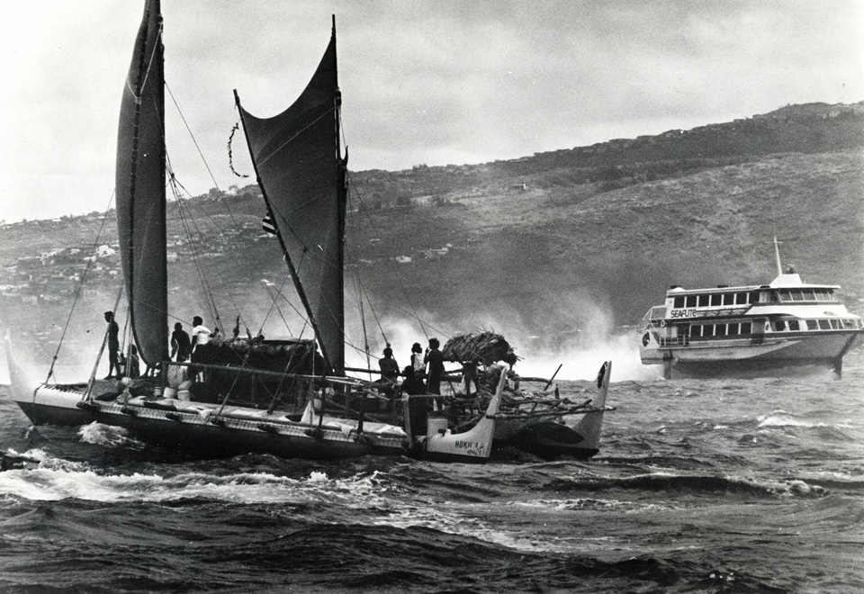
Hokule’a circa 1976, https://www.staradvertiser.com/2014/05/13/hawaii-news/tuesday-004/

While there was a lot of success with Hokule’a, there were mishaps on the voyages, with pieces of the ship breaking in rough seas. The journey was planned by the Polynesian Voyaging Society and was a 30 day, 2,500 mile journey from Hawaii through the Tahaitian island chains, following the routes taken by ancient Polynesian Migrants. The Hokule’a left Magic Island, Oahu on March 16th 1978, bound for Tahiti. There was a gale warning in effect that day, but Captain Dave Lyman decided to leave as the weather was forecasted to moderate later in the day, and the Hokule’a had sailed in those conditions before. The ship unfortunately met a storm and developed a leak in one of the hulls and capsized 12 miles south of the island of Molokai. Will Kyselka in An Ocean in Mind describes conditions, “Swells were high, but the canoe had ridden out such seas before. However this time it was heavily laden with food and supplies for a month’s journey. The added weight put unusual stress on the canoe, making it difficult to handle. Turning off wind eased the strain but it also caused the sea to wash over the gunwales, filled the starboard compartments and depressing the lee hull.”

Eddie and the crew (16 members in total) clung to the hull of the capsized vessel, trying to protect themselves as best as they could. They saw airplanes fly overhead, but no one saw them, and the Hokule’a was quickly drifting away from airline routes which decreased their chances of being spotted. First, crew member Snake Ah Hee left on a surfboard to try to get aid, and when a low flying plane appeared, he assumed that the ship had been spotted and returned. But after waiting a few hours, it was clear that no one was coming to their rescue. Around midnight a large wave hit the partially submerged canoe and fully turned her over.
The crew took shelter on the leeward hull, standing on the running board, they had put on foul weather gear and had gathered supplies. They had fired flares at passing aircraft, but no one noticed, and the crew wasn’t able to raise anyone via radio.

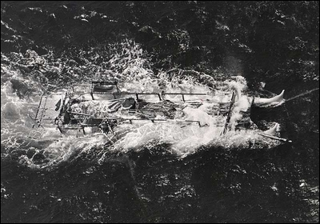
Wreck of the Hokule’a https://archive.hokulea.com/holokai/1978/voyage_cancelled.html

The next morning, the crew was starting to be in bad condition - crew member Kikili Hugho recalls, “We were like hours away from losing people. Hypothermia, exposure, exhaustion.” It was then that Eddie decided to go for help, and was given permission at 10:30 am. Navigator Nainoa Thompson paddled out with him for a while to test the waves, and then Eddie went alone, pointed toward the nearby island of Lanai to try to get help and get the crew rescued. He removed his life jacket as it was hindering the paddling of the surfboard. Will Kyselka spoke of this “Eddie would go alone. The crew, clinging to the overturned hulls, watched in silence as he rode the waves into a fate unknown to many of the people of old who sailed toward distant lands.” The crew joined hands in prayer and wished Eddie strength and luck as he departed. Kikili Hugho recalled, “When Eddie paddled away, I really thought he was going to make it and we weren’t. That’s how bad it was, that we were doomed.”

At 3:30 in the afternoon, a ship passed but did not see them. At 8:47, flares from the canoe were finally spotted by the last Hawaiian Airlines flight from Kona on the Big Island. The plane circled overhead and flashed it’s landing lights, then reported the sighting to the U.S. coast guard. Hugho stated, “We were close to dying out there. At 7:15 or 7:30 we started looking at the Kona direction for the last flight coming out of Kona. The flight left Kona slightly late, and the pilot altered the flight path to compensate. It was a miracle find, a miracle rescue.”
At 1:20 AM on March 18th, the coast guard cutter Cape Corwin arrived at the Hokulea’ which had drifted 2 miles west of where it was first cited. The remaining 15 crewmembers were rescued and the canoe was righted and towed in the following morning.
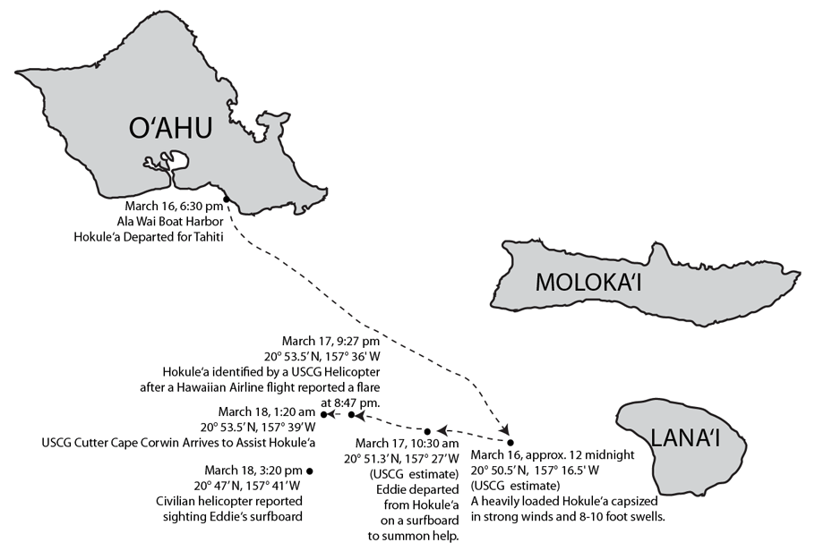
Drift of the Hokule’a https://archive.hokulea.com/holokai/1978/voyage_cancelled.html

The search for Eddie was the largest air-sea search in Hawaiian history, but Eddie Aikau was never seen again. Nainoa Thompson said of his efforts “At a deeper level, Eddie tried to rescue not only the crew of the Hokule’a but the symbolism and dignity of the canoe, because he knew it carried the pride of his people.” The Hawaiian and more specifically, the North Shore community was devastated by the loss of the now famous lifeguard and surfing champion. Nainoa Thompson reflected, “After Eddie’s death, we could have quit. But Eddie had this dream abotu finding the islands the way our ancestors did and if we quit, he wouldn’t have his dream fulfilled…He was a lifeguard…he guarded life, and he lost his own, trying to guard ours.” Safety precautions were heightened in the Polynesian Voyaging Society after this including regular radio communication, and hatch covers being made airtight. Checklists and procedures were developed, and training programs more rigorous. Today, the Hokule’a regularly circumnavigates the entire globe today, and carries a placard dedicated to Eddie.

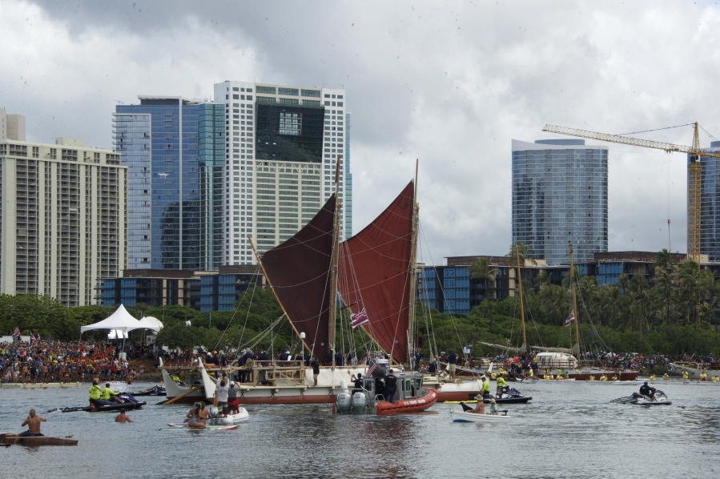
Hokule’a in Honolulu, 2017, following 3 year journey around globe, https://www.columbian.com/news/2017/jun/17/canoe-returns-to-hawaii-after-round-the-world-voyage/
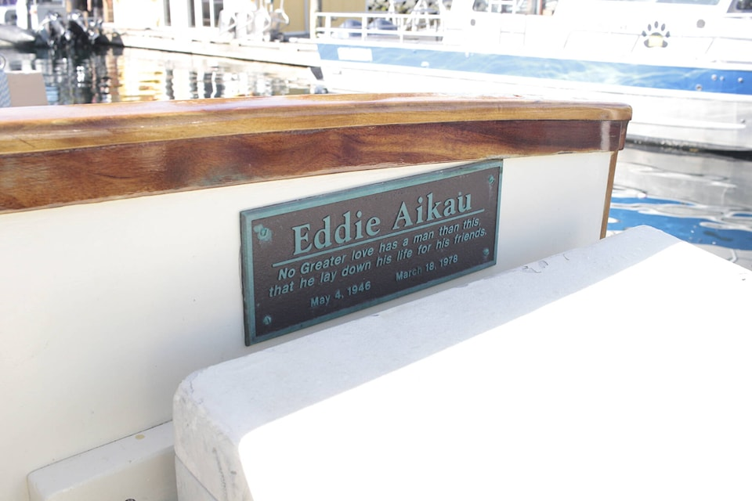
Eddie’s memorial on the Hokule’a, https://www.bpmcdn.com/f/files/victoria/images/feeds/gps/2023/08/web1_230803-crm-hokulea-voyage-hokulea_6.jpg;w=960
In 1984, The Quicksilver In Memory of Eddie Aikau surfing event was established at Sunset Beach, and later moved to Waimea Bay until modern day. The event was renamed the Eddie Aikau Big Wave Invitational in 2019/2020 and only runs when swells reach a minimum height of 20 feet. Due to the requirements of the competition, the event has only been held eight times since its inception in 1984. One event organizer describes the event “It has to be big for this thing to run. Really big. Scary big. Sacred big.” The competition is open to both ASP tour champions and locals alike, but the Aikau family personally chooses the entrants into the competition. To open the waiting period for the waves in the winter, surfers paddle out to a recreation of the Hokule'a together out of ceremonial respect for Eddie. “One year, when the waves met the height requirement but appeared too dangerous to surf, organizers considered calling it off,” surfer Mark Foo turned to a cameraman who was capturing the surf and said what is now Eddie's classic motto “Eddie would go.” That year, the event was held, because Eddie would go.
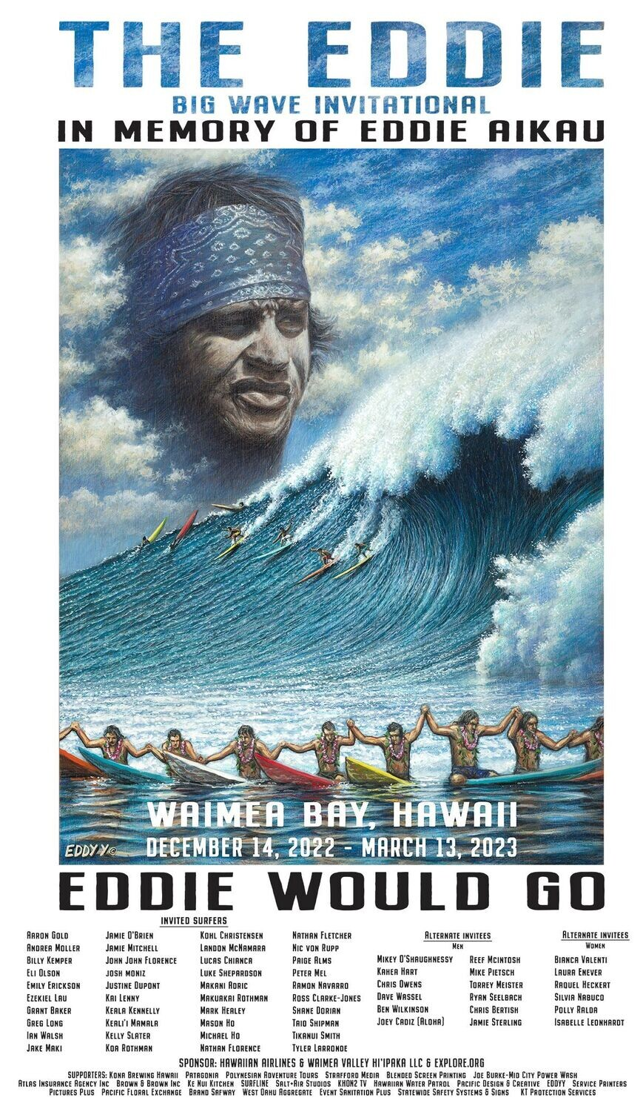
Most recent poster for the invitational, https://d2j6dbq0eux0bg.cloudfront.net/images/83949252/3608736478.jpg

Duke Kahanamoku and Newport Beach Rescue

Duke Kahanamoku and The Superhuman Rescue, Gordy Grundy, The Inertia https://www.theinertia.com/surf/duke-kahanamoku-and-the-superhuman-rescue/

Heroic efforts of “Duke” of Corona del Mar Remembered, David Henley, Daily Pilot https://www.latimes.com/socal/daily-pilot/news/tn-dpt-me-0820-duke-rescue-20150819-story.html

Duke Kahanamoku Part 2: The Day He Saved Eight Souls, Roy Tomizawa, The Olympians https://theolympians.co/2016/07/20/duke-kahanamoku-part-2-the-day-he-saved-eight-souls/

The Duke Kahanamoku Story, Duke Kahanamoku.com
https://dukekahanamoku.com/the-duke-kahanamoku-story/

Duke Kahanamoku is one of the world's most famous surfers and is generally considered the “Father of Modern Surfing”. Duke was a native Hawaiian, born in Honolulu on August 24th, the first of nine children to Duke Halapu and Julia Paoa Kahanamoku. As a kid growing up near Waikiki Beach, he developed swimming and surfing skills and preferred boards constructed from native Koa wood at 16 ft long and weighing 114 lbs. At this point, surfing was pretty much unknown to the rest of the world, but was considered traditional heritage by native Hawaiians. By 1911, Duke was breaking records at his very first swimming races in Honolulu harbor with 3 freestyle world records broken by at least 4.6 seconds.

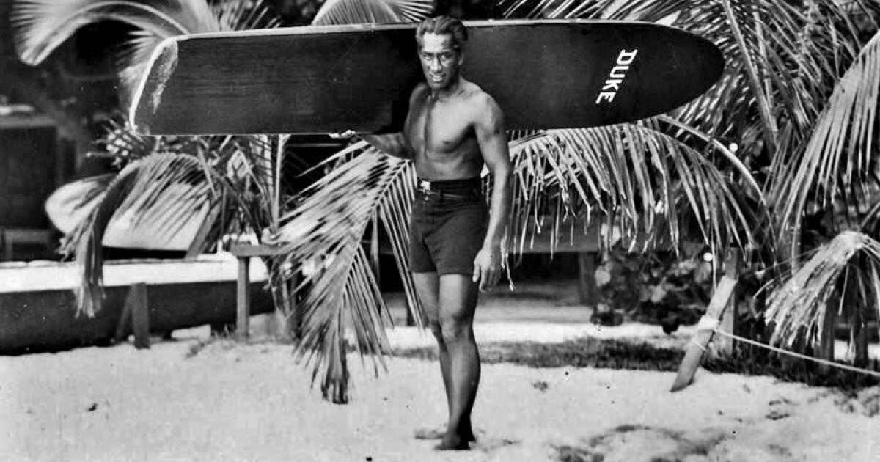
https://www.latimes.com/local/lanow/la-me-ln-duke-kahanamoku-surfer-20150824-story.html

In 1912 he became an Olympian, winning 2 Olympic medals at the 1912 Stockholm Olympics, setting another record for the gold in a 100 m freestyle and winning silver with the U.S. freestyle relay team. With his Olympic fame, he began introducing surfing to the U.S., Australia, and New Zealand and helped popularize surfing in the U.S., especially in Southern California. In 1918 he also swam in over 30 exhibitions in mainland cities to raise money for the WWI war effort. In 1920 he won two more gold medals at the Antwerp Olympics for the 100 meter freestyle and with the U.S. freestyle relay team. In 1924, he rounded out his olympic career with a silver medal in the Paris Olympics for the 100 m freestyle.

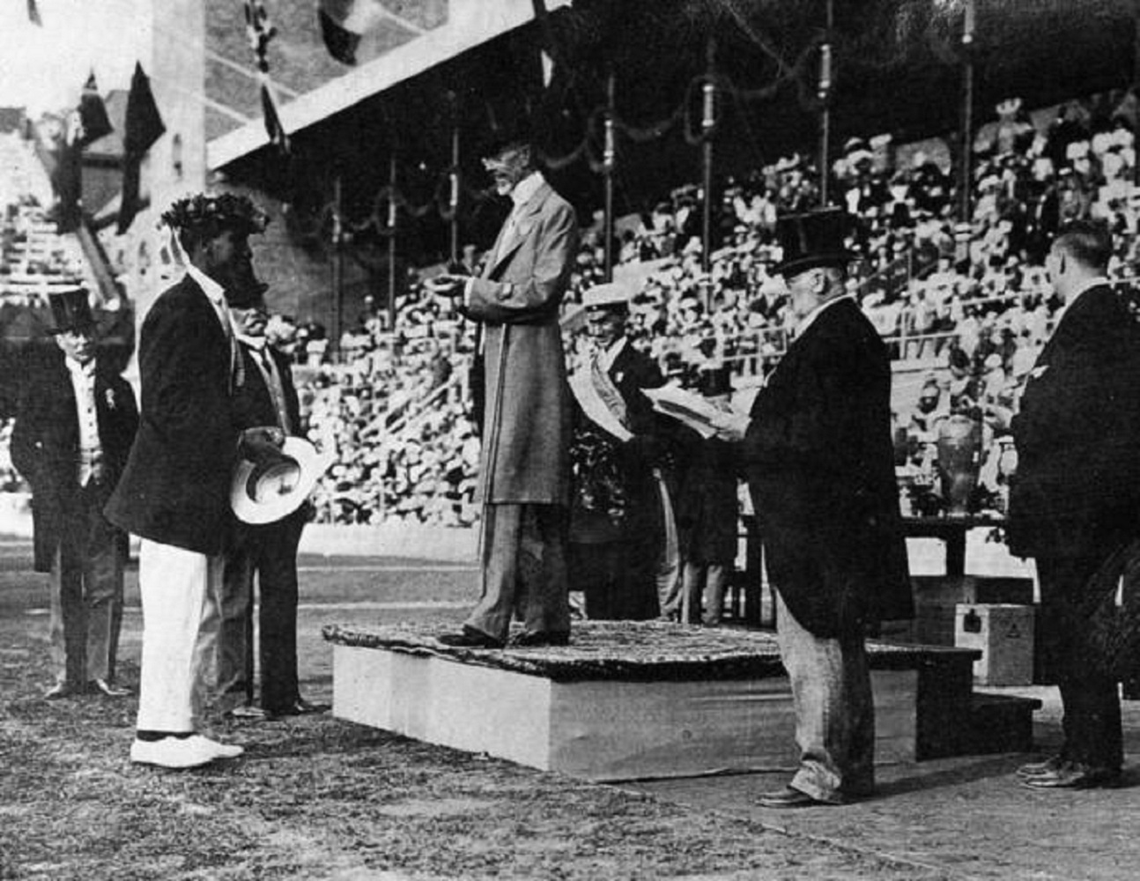
Duke receiving Olympic Gold at the 1912 Stockholm olympics. https://simple.m.wikipedia.org/wiki/File:Duke_Kahanamoku_accepting_the_Olympic_Gold_Medal_from_King_Gustav,_Stockholm,_Sweden_1912.jpg

In 1925, Duke Kahanamoku was living in Los Angeles after his Olympic wins and giving swimming exhibitions at the Los Angeles Athletic Club. He was 35 at the time. Before the event we are talking about today, Duke was also traveling the California coast with his other surfing friends, slowly but surely popularizing the sport in southern California. He didn’t have a ton of money, but he had a lot of friends, and he always had a car filled with surfboards, including a few long redwood boards. At the time, Hawaiian and South Pacific culture was very popular, and people all over the mainland were fascinated, turning tiki and surf culture into a craze. Duke was visiting Newport Beach in June with a few friends to catch some waves brought in by a Chubasco, or an unexpected and swift squall with thunder and lightning. They are common during the rainy season on the Pacific coast of Southern California, Mexico, Central America, and South America.

Duke and his two friends, Owen Hale and Jerry Vultree were camping out on the beach, awaiting the waves. Duke knew the beaches and loved surfing Newport at Corona Del Mar, which was a similar wave to those he experienced in Waikiki. At the time, in 1925, Newport Beach was a “rough and tumble” town, and wasn’t even technically a port. The entrance to the harbor could be dangerous to ships, but offered the “best surfing in the world” to surfers at the time. In the book Surfing Newport Beach by Claudine and Paul Burnette, they stated that Duke “rode the waves of Newport Bay in a canoe, and when he could, he borrowed an actual surfboard from his friend Felix Modjeski…Eventually, Duke and some of his friends brought down their own surfboards to Corona del Mar and left them at the Sparr Bathhouse, starting what would become one of the first surf clubs in the U.S. – the Coronal Del Mar Surf Club.”
Robert Guardner talked about the club at the time “The Duke asked me to watch over their boards (at the Sparr Bathhouse) and see to it that no one stole them. Steal them? An average man couldn’t even lift one. They were made of mahogany, twelve feet long, probably six inches thick and weighed well over two hundred pounds…the Duke asked me to watch over the boards. I did so, and in return, he would take me out for a ride on his shoulders. He was a powerful man, and I weighed less than a hundred pounds, so by what seemed no more than a flick of the wrist he had me on his shoulders and probably didn’t even know I was there during the ride.” At the time, in 1925, surfing was considered an oddity, an ancient Hawaiian skill that had only been introduced to the United States recently.
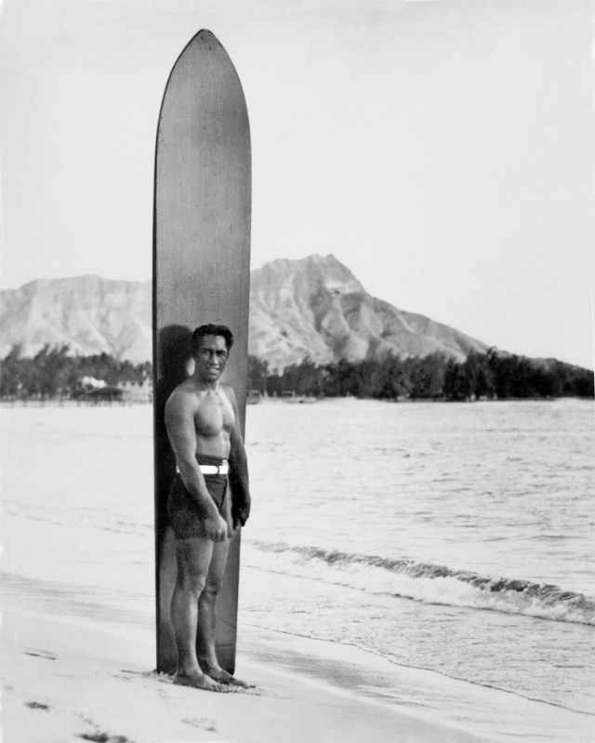
Duke in Waikiki with one of his giant boards, https://www.rockawave.com/articles/duke-kahanamoku-father-of-surfing/

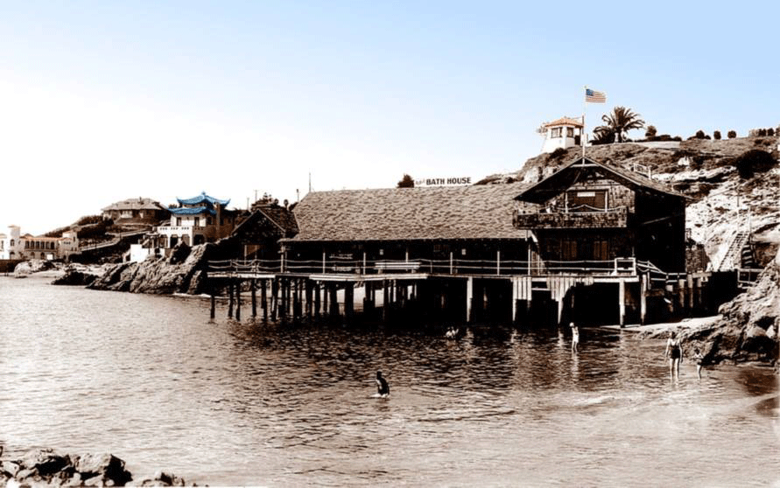
Corona del Mar Surf club, https://twitter.com/cdmhistorical/status/1212143634667061248

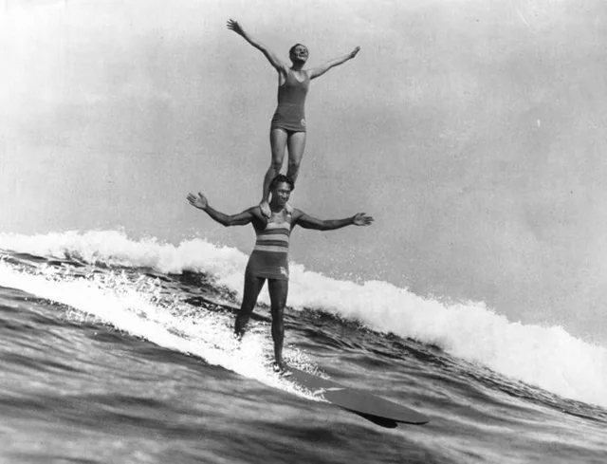
Duke surfing at Corona del Mar in 1922 https://www.reddit.com/r/OldSchoolCool/comments/146pa0b/duke_kahanamoku_the_father_of_modern_surfing_and/
On June 14th, 1925 as the chubasco came through southern California, Newport beach harbor was hit by unrelenting swells from 20 to 30 ft in height and sandbars at entrance to the harbor were shifting. Storms like these had caused deaths in Newport Beach before, as just a year earlier on June 8th, the 30 ft fishing boat Adieu overturned during a storm off Corona del Mar. Five of the 17 passengers and crew drowned during the event. On May 21st, just three weeks before this storm, a rowboat carrying three teenagers capsized in the waves, drowning one of them before they could get to safety.

This storm was no exception. Disaster struck as the Thelma, a 40 ft, 5 ton sport fishing yacht tried to enter the harbor. A huge wave smashed the bow of the Thelma, flooding the engine room. The vessel, according to the LA times, “was caught broadside in the teeth of three tremendous breakers and rolled completely over three times from starboard to port on the sand of the shallow bar….The swell, as it gained momentum, merged into a mountainous wave and crashed over the bow, smashing the plate glass window of the engine room. Practically all the members of the pleasure party were swept overboard with the first wave and were struggling in the midst of the torn wreckage and pounding waves.” None of the 29 fishermen had time to grab a life preserver before they were violently thrown into the water. In the book Legendary Surfers, Malcolm Gault Williams stated of the ordeal “From shore, we suddenly saw the charter fishing boat, the Thelma, wallowing in the water, trying to get to safe water and it was a losing battle. The prospects for picking up victims looked impossible.” Duke spoke of watching the ship flounder, “Only a porpoise or sea lion had the right to be out there. From the shore we saw the Thelma wallowing in the water just seward of where the breakers were falling. You could see her rails crowded with fishermen. She appeared to be trying to fight her way toward safe water…but obviously it was a losing battle. A mountain of solid green water curled down upon the vessel…spume geyser up in all directions…then before the next mammoth breaker could blot out the view again, it was obvious the Thelma had capsized and thrown her passengers into the roiling sea.”

Duke and two of his surfing buddies decided that they needed to jump into action, and hopped onto their boards. Duke paddled through the pounding waves to get to the drowning men, and just started rounding them up. He stated of the ordeal, “Don’t ask me how I made it, for it was just one long nightmare of trying to shove through what looked like a low Niagara Falls,” Duke said, adding that the waves were “building up to barn-like heights.” At this point, everyone on board the Thelma was in the water with nothing to hang onto, and everyone was fully clothed, which was weighing them down in the choppy pounding surf. Then the rescue began in earnest. Duke described the ordeal, “I reached the screaming and gagging victims and began grabbing at their frantic arms and legs. I brought one victim on my board, then two on another trip, possibly three on another, then back for one. It was a delirious shuttle system. In a matter of minutes we were making rescues; people were screaming, gagging, thrashing. Some victims we could not save at all, for they went under before we could get to them. We lost count of the number of trips we made. Without the boards, we would probably not have been able to rescue a single person.”

Duke and his friends succeeded in rescuing twelve individuals, but seventeen of those fishermen drowned. Duke himself was responsible for eight of the rescues. Those rescued were taken to two area hospitals with serious injuries including broken arms and legs.Jerry Vultee and Owen Hale also were hospitalized for injuries sustained during the rescues. Captain James Porter, who was the Newport Beach Chief of Police said, “Kahanamoku’s performance was the most superhuman rescue act and the finest display of surfboard riding that has ever been seen in the world. Many more would have drowned but for the quick work of the Hawaiian Swimmer.” Duke later spoke of the rescue, saying, “Neither I or my pals were thinking heroics…we were simply running…me with my board and the others to get their boards…and hoping to save lives. I hit the water very hard and with all the forward thrust I could generate I paddled until my arms begged for mercy.”

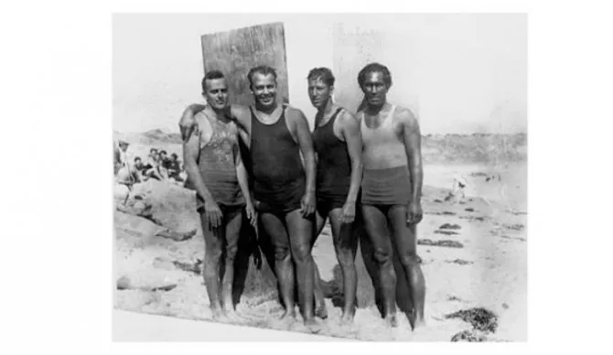
From left to right: Gerry Vultee, Owen Hale, Bill Herwig and Duke Kahanamoku. ,Courtesy of Paul Burnett

Following the ordeal, Duke didn’t stick around to try to get media attention for his rescue, leaving before reporters arrived. The story made national news, and the event is often referred to as “The Great Rescue of 1925.”, and Duke received nicknames such as “The Great American Hero” and “The Great Human Fish.” Following this, he appeared in fifteen movies, playing small roles such as an “Indian” chief, lifeguard, Turkish sultan, and wild animal trainer, and playing himself in two documentaries. He also appeared with John Wayne in the movie “Wake of the Red Witch.” as the South Pacific chief Ua Nuke. Duke served as the sheriff of Honolulu for 12 years from 1934-1959 and married for the first time at the age of 40 to dance instructor Nadine Alexander. He continued to win Olympic medals at 42 when he won a Bronze medal as an alternate on the U.S. water polo team at the LA Olympics, making his Olympic career span 20 years. Upon becoming a state in 1960, Duke was appointed the state’s Official Ambassador of Aloha.

Jerry Vultee went on to found the Vultee Aircraft Corp. which built the U.S. Army’s iconic V-II dive bomber. 13 years after the Thelma rescue, on January 29, 1938, Vultee was piloting a small single engine plane from LA to NYC with his wife, Sylvia, on board, when a heavy snowstorm forced him to go off course and stop for fuel in Winslow Arizona. When attempting to land, Vultee lost his bearings and crashed into a tree near Sedona. It took rescuers a day to reach the wreckage, where they found the bodies of Jerry and Sylvia, leaving their 6 month old child an orphan.

Duke succumbed to a heart attack at the age of 77 on January 22, 1968. His ashes were scattered in the Pacific off Honolulu. Statues of Duke Kahanamoku have been erected on Huntington Beach in California and Waikiki Beach in Honolulu, and he was inducted into the Huntington Beach Surfers’ Hall of Fame, International Surfing Hall of Fame, and U.S. Olympic Hall of Fame. To continue to support Duke’s Aloha spirit, you can donate to The Outrigger Duke Kahanamoku Foundation - this foundation financially supports the development of individuals and organizations that perpetuate the spirit and legacy of Duke Kahanamoku. This foundation awards scholarships for scholar athletes from Hawaii and inducts members into the Hawai’i Waterman Hall of Fame.

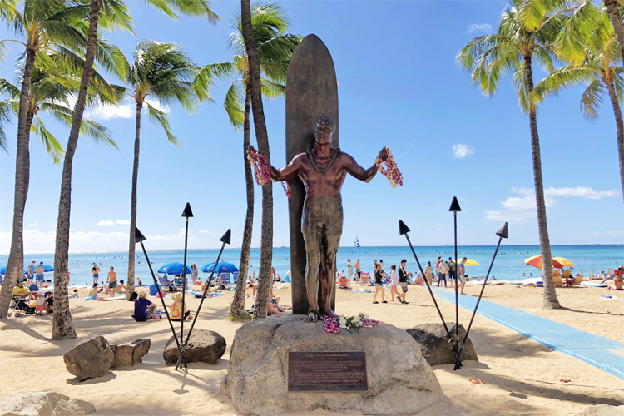
Duke Kahanamoku statue in Waikiki, https://www.surfertoday.com/surfing/the-statue-of-duke-kahanamoku

Before this rescue, surfboards had never been considered as a possible life saving device on the mainland. “The rescue helped sell lifeguard service on the wisdom of keeping paddleboards at the guard towers. The boards soon became standard equipment on the emergency rescue trucks as well as the towers. In short, some good comes from the worst of tragedies.”

