Episode 70 - Floyd Collins and Sand Cave

Tragedy at Sand Cave, Mammoth Cave National Park https://www.nps.gov/articles/000/tragedy-at-sand-cave.htm

The Kentucky Cave Wars, Mammoth Cave National Park, https://www.nps.gov/articles/000/the-kentucky-cave-wars.htm

https://en.wikipedia.org/wiki/Mammoth_Cave_National_Park

The Agonizing Death of Floyd Collins, The Cave Explorer Who Was Trapped Underground for 17 Days Before He Finally Perished, Austin Harvey, All That Is Interesting. https://allthatsinteresting.com/floyd-collins

Floyd Collins was born on June 20, 1887 in Logan County Kentucky to Lee Collins and Martha Jane Burnett, and from a young age, he developed a hobby of exploring caves which littered the county in which his family farm sat. By the age of 20, in 1917, Floyd discovered Crystal Cave beneath his father’s farmland. He quickly began developing the cave into a tourist attraction, as the cave boasted unique helictite and gypsum cave formations, leading to the name “Crystal Cave”.
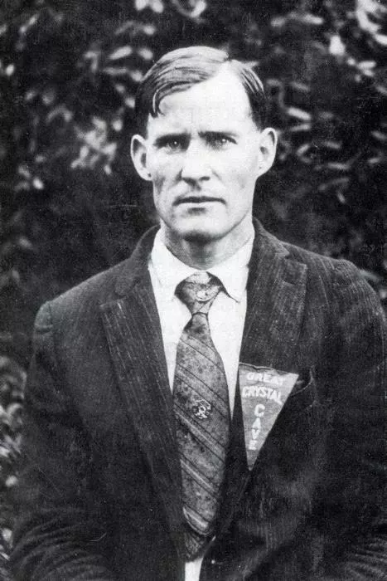
Floyd Collins, Mammoth Cave National Park https://www.nps.gov/articles/000/tragedy-at-sand-cave.htm

During the early 1900s, cave tourism and show caves were a lucrative and very competitive business. Due to aggressive and highly suspicious practices between rival cave owners, the era became known as the Cave Wars in Kentucky Cave Country. These “wars” started when communities sprang up around the famous Mammoth Cave in the mid-1800s, and other smaller caves were discovered. It was very lucrative to local landowners to have a successful cave touring business, and the smaller caves were often smaller and showier. Location was important, and if a cave wasn’t near the stagecoach lines to Mammoth Cave or later, the Mammoth Cave Railroad, business was unlikely to survive. The Cave Wars reached a feverish pitch in 1915 when George Morrison found a connecting passage, a “back-door” to the now world famous Mammoth Cave through his property. While he was accessing the cave illegally, no one could really stop him. At this point, cave owners battled with marketing, with the roadsides lined with competing signage, and solicitors known as “cave cappers” lined the highways to try to draw tourists to their caves. While the cave wars did not end in the formation of Mammoth Cave National Park in 1941, a big event did change the way Kentucky’s cave country was viewed. By the 1960s, however, much of the private owned cave businesses had dried out and only the national park remained.

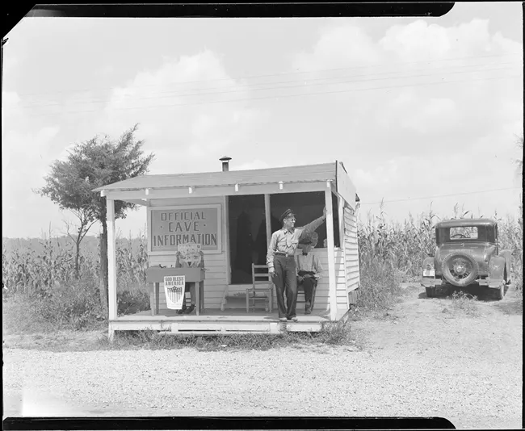
“Cave Cappers” for Great Onyx cave working to lure tourists in, https://www.nps.gov/articles/000/the-kentucky-cave-wars.htm

Unfortunately, Crystal Cave made little profit due to it’s remote location on Flint Ridge Road, and visitors would pass by many other caves showing similar views. Floyd knew there was another cave located on Beesly Doyel’s property known as Sand Cave which was situated on Cave City Road, where many of the show caves were. Floyd entered into an agreement with Beesly Doyel to both explore the cave and share profits if the cave proved worthy to be advertised to tourism. The cave was said to have a magnificent subterranean coliseum about 80 ft high, only 300 ft. from the cave’s entrance, so it could be a big draw for tourists. He entered the cave on January 30th, 1925 in the morning with a single kerosine lantern. He found the cave offered many challenges, including tight squeezes, one he could only inch through on his stomach with one arm stretched ahead of him, pushing the lantern, and the other at his side. It was at this point that his lantern began to flicker. He knew it would be extremely dangerous to lose his only light source, so he reluctantly began to return.As he turned back through the tight squeeze, his foot dislodged a 27 lb rock that wedged his ankle in place. He tried everything to remove his foot from underneath the rock, but due to his awkward position he could not. In his attempt the free himself, he ended up burying himself up to his waist in rubble. “He was trapped in a stone straight-jacket” (William “Skeets” Miller), 60 feet beneath the earth's surface.

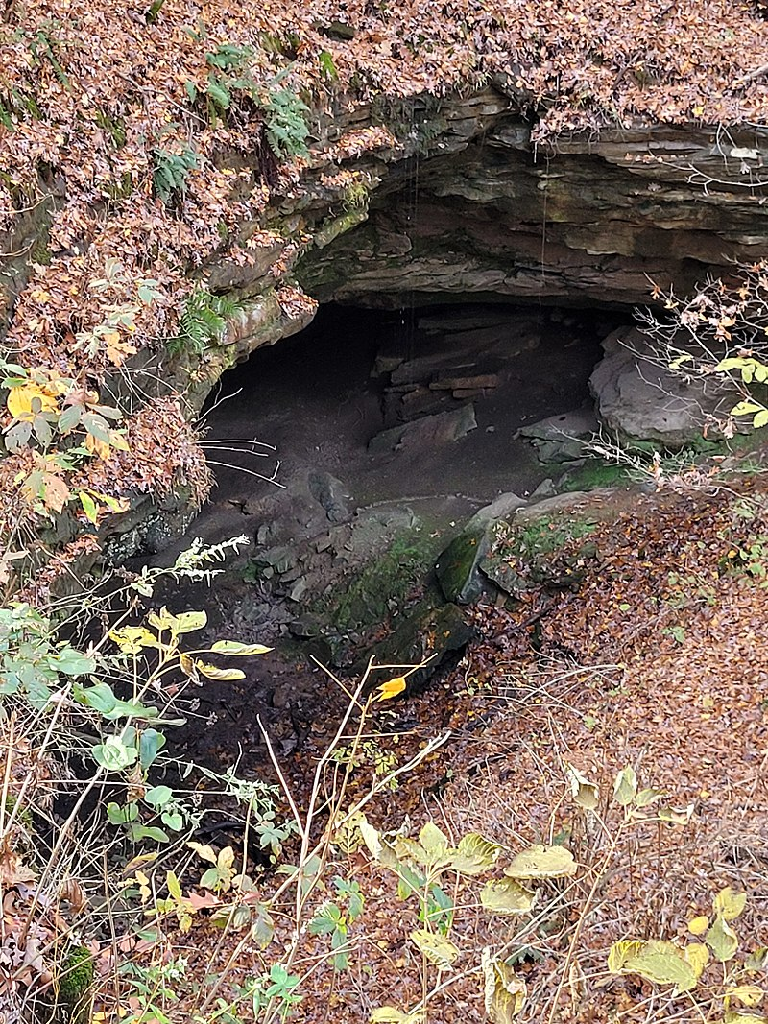
Entrance to Sand Cave, https://en.wikipedia.org/wiki/Floyd_Collins#/media/File:Sand_Cave_at_Mammoth_Cave_National_Park.jpg

The following morning, neighbors realized that Floyd did not come home and set out to look for him, finding his coat hanging up outside of Sand Cave. Because the cave passage ways were so tight and narrow, the only person who could reach him was a 17 year old boy, Jewell Estes. Jewell managed to climb back far enough to communicate with Floyd, and it was then they realized he was trapped. Once it was discovered that Floyd was trapped in the cave, the neighbors notified Floyd’s family, and his brothers, Homer and Marshall came, bringing Floyd food and water and beginning the rescue attempt.
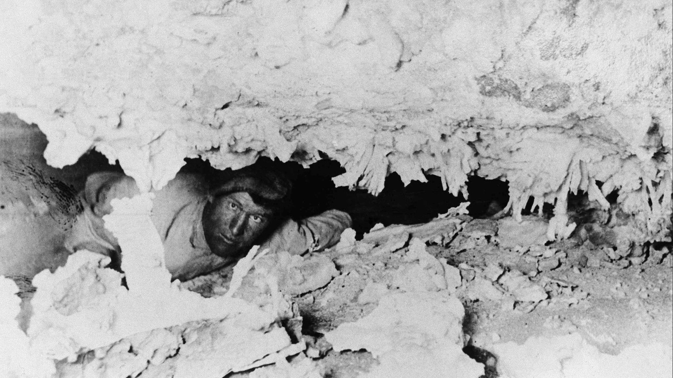
Floyd trapped in the cave, https://www.baltimoresun.com/features/retro-baltimore/bs-md-retro-trapped-cave-floyd-collins-20180713-story.html

In the following days, the rescue attempt begins in earnest, as Homer attempted to dig Floyd free with no success. Locals began gathering around the entrance of the cave to see what was happening with Floyd, and Marshall offered $500 to whoever could free his brother. Many volunteers bring food and drink down to Floyd to relieve the brothers, but get scared in the dark passageways, often stashing the items in cracks and crevices, never getting provisions to Floyd. By Feb 2nd, Floyd was in rough shape due to the conditions of the cave and the lack of food and water. He was shaky, cold, numb and experienced periods of stupor and lucidity. News had begun to travel, however, and journalists began to arrive, including a journalist from Louisville Courier-Journal named William “Skeets” Miller. He was called “Skeets” due the fact that he was the “not much bigger than a mosquito” Because of this, he was able to enter the cave and speak to Floyd, but upon seeing the situation Floyd was in, he forgot about the news story and began assisting in the rescue attempt. Miller says of the experience, “My flashlight revealed a face on which is written suffering of many long hours, because Collins has been in agony every conscious moment since he was trapped at 10 o’clock Friday morning. I saw the purple of his lips, the pallor on his face, and realized that something must be done before long if this man is to live,” he wrote for the Chicago Tribune.

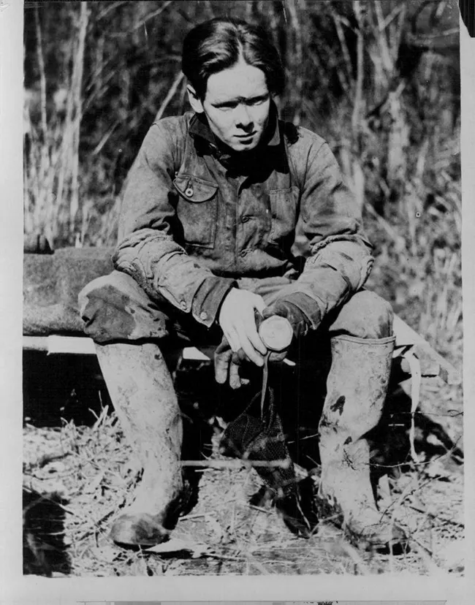
Journalist “Skeets” Miller during rescue, https://www.nps.gov/articles/000/tragedy-at-sand-cave.htm

At this point, Lieutenant Robert Burdon (from the Specialist Police-Fire Rescue Team) arrived on scene and attempted to free Floyd by using a harness around his chest to pull him out, which just results in a lot of pain and no success. A caving buddy of Collins’s John Gerald also arrived, attempting to dig him out, again with no success. About 200 ppl had gathered outside the cave, erecting tents, one to sell hot coffee and snacks, and one for first aid.

By Feb 3rd, the story became the top in the nation, and rifts began developing between rescuers. Three men try to convince John Gerald to let them chisel at the rock above Floyd, but Gerald was convinced that it would do more harm than good, and doesn’t allow them to move forward. Henry St. George Tucker Carmichael, the superintendent of the Kentucky Rock Asphalt Company, arrived with workers, with the first attempt at an organized rescue. They scouted out a rescue shaft location, all though other rescuers are concerned about a collapse that would kill Floyd. Carmichael eventually agrees, so the men began moving rocks from the cave passageway instead to make other rescue attempts easier. Skeets and others rigged an electrical system with light bulbs and a 32 volt generator to allow Floyd to have light and warmth in the cave. Lieutenant Burdon returned to attempt another pulling scheme, but Gerald got in a huge fight about the best plan of action. At this point, most of the rubble had been removed from around FLoyd’s body and the idea of using jacks to prop the rock is being discussed. Unfortunately, when the plan was put into action, the small jack continued to slip, and no further progress was made.. Floyd convinces the rescuers to get some rest and come try again in the morning. At this point, tensions are arising between outsiders and locals, and the national guard is brought in to assist with crowd control.

Feb 4th, Floyd was in better shape than he was over the past three days, as he had finally gotten food and water. The jack idea was attempted again, but the cave was showing signs of crumbling, indicating the passageway was unstable. It was thought that both the jack and the number of people (rubbing against walls and creating body heat) increased the chance of collapse. Debris began falling and there was officially a cave collapse, separating the teams from Floyd. Gerald attempts to dig out the collapse, but another collapse happens in this passage. Floyd was now cut off from his rescuers.

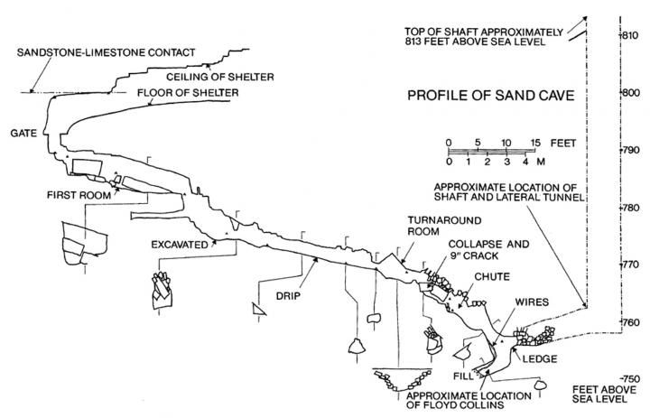
A diagram of the situation, https://i.pinimg.com/736x/72/a9/9e/72a99e2875382a6251148ae652253844.jpg

Feb 5th, National Guard Brigadier General Henry Denhart was placed in command of rescue. Carmichael began supervising the creation of a 6 x 6 vertical shaft to rescue Floyd. The only tools allowed were picks and shovels, because anything stronger may cause the cave to collapse on Floyd. A work force of 75 men worked round the clock on this shaft.

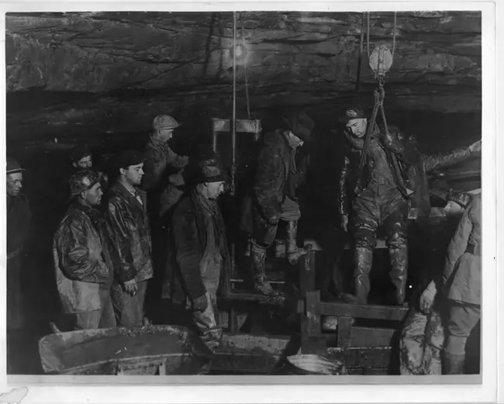
Rescuers attempting to dig a shaft to reach Floyd, https://www.nps.gov/articles/000/tragedy-at-sand-cave.htm

By Feb 6th Floyd has been trapped for a week, and work on the shaft progresses at a snails pace, all though it has reached 17 ft deep. By Feb 7th, the crowd is becoming uncontrollable outside, so the National Guard erects a barb-wired fence around the site. Several people try to look for other entrances to gain access to Floyd from another passageway, but it’s unsuccessful. Feb 8th was nicknamed “Carnival Sunday” since 10,000 people are at the cave site in hopes to see rescuers pull Floyd out. Vendors are selling food, alcohol and booze, and the atmosphere is more cheerful than morose, like visitors are at a county fair instead of a harrowing rescue. The shaft was still only 23 ft deep. Journalists begin making accusations that not enough was done in the beginning to save Floyd, other rumors arise saying it’s just a publicity stunt to try to get people to come visit Floyd’s Crystal Cave.

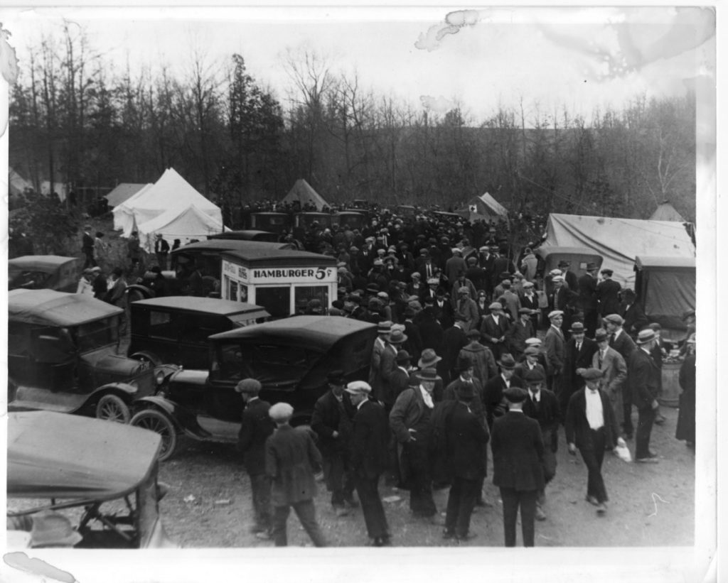
The Crowd outside the cave, https://media.defense.gov/2021/Jun/07/2002736340/-1/-1/0/250210-Z-DO489-002.JPG

By Feb 9th, the view of whole ordeal is very negative, and there are four main theories of the situation:
- It’s a hoax to lure tourists to Kentucky’s Cave Country
- Floyd was murdered by someone unknown in the cave
- Food and water are being purposely withheld so he will die
- Floyd is still alive and travels out of the cave and back each night.

On Feb 10th, a military court convened in Cave City to clear up suspicions of criminal activity and disprove that Floyd’s entrapment is a hoax. Rain slows progress on the shaft. By Feb 11th, a cold front had moved in and snow fell, and the temperature dropped into the 20s, hindering the rescue effort. By Feb 12th, Floyd had been trapped for 13 days and had not eaten in over a week,ever since the second cave collapse occurred. The shaft was now 48 ft and needs constant shoring to avoid collapse. On Feb 13, the shaft reached 52 feet, and on the 14th it reached 55 feet. They were desperate to reach Floyd at this point so they began digging laterally to reach him faster and prevent the sides of the shaft from slumping. Due to a heavy rain, there was now 2ft of standing water at the bottom of the shaft that needed to be pumped out. By the end of the night on the 15th the lateral tunnel was within several feet of Floyd.

Finally, by 1:30 PM on Feb 16th, they broke through to a Sand Cave Passage where Floyd is found dead. The cause of his death was exposure, exhaustion, and starvation. It's estimated he has been dead for 24 hours. They decided to leave Floyd’s body inside, as his leg was still trapped and the rescue shaft was slumping at an alarming rate. Rescuers decided they didn’t want to risk any more lives. Sand Cave was sealed with Floyd’s body inside, but months later the body would be removed for a formal burial closer to the family’s home near Crystal Cave.
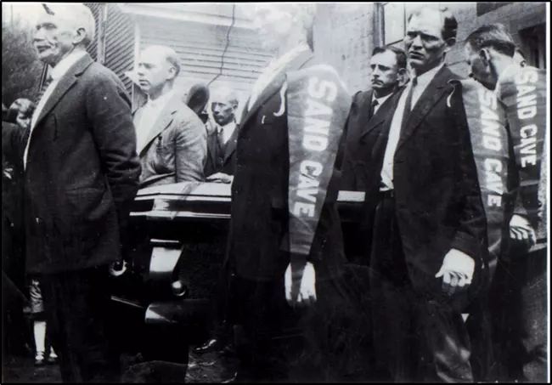
Pallbearers carrying the coffin of Floyd, https://www.nps.gov/articles/000/tragedy-at-sand-cave.htm

The media circus and the story of Floyd captivated the attention of the country and brought many changes to the community in Cave Country. Skeets Miller earned the Pulitzer Prize from his Sand Cave interview of Floyd, and his dive into the rescue efforts. But this was not the end for Floyd, or rather, Floyd’s body. Later in 1927, a man called Dr. Harry Thomas purchased Crystal Cave, exhumed Floyd’s body, and put him in a glass topped coffin in the center of the cave to draw in tourists, with a headstone stating “Greatest Cave Explorer Ever Known.” Even stranger, a visitor attempted to steal Collins’ body, and in 1929, another person did managed to steal Collins’ corpse. Authorities managed to track him down, but Floyd Collins lost a leg in the process.

Mammoth Cave National Park purchased Crystal cave in 1961, and limited access to the tomb, but eventually gave the poor guy a proper burial in 1989 at Mammoth Cave Baptist Church. The story would go on to later inspire books like Trapped! Written By Robert K. Murray and Roger W. Brucker, and the Life and Death of Floyd Collins written by Floyd’s brother Homer Collins. There was also a musical called Floyd Collins, and a 1951 Hollywood film called Ace in the Hole inspired by the story. Due to this event, national attention was drawn to Kentucky’s cave country with a newfound desire to protect it, which eventually led to the establishment of Mammoth Cave National Park in 1941.

Mammoth Cave is formally known as the Mammoth-Flint Ridge Cave system, and in total, more than 426 miles of passageways have been surveyed. It is the longest cave system in the world. Floyd Collin’s Crystal Cave is now known to connect to the greater Mammoth Cave System. The caves in this area were formed when water slowly dissolved a massive limestone slab beneath the surface of sandstone, creating amazing passageways, cave formations, and crystals over millions of years. Animals that call the cave home include five species of bats, two genera of crickets, the spotted-tail salamander, two genera of eyeless cavefish, a cave crayfish, and a cafe shrimp. The national park service now offers guided cave tours to visitors, from one to six hours in length, all though some “wild” tours provide a more authentic spelunking experience.

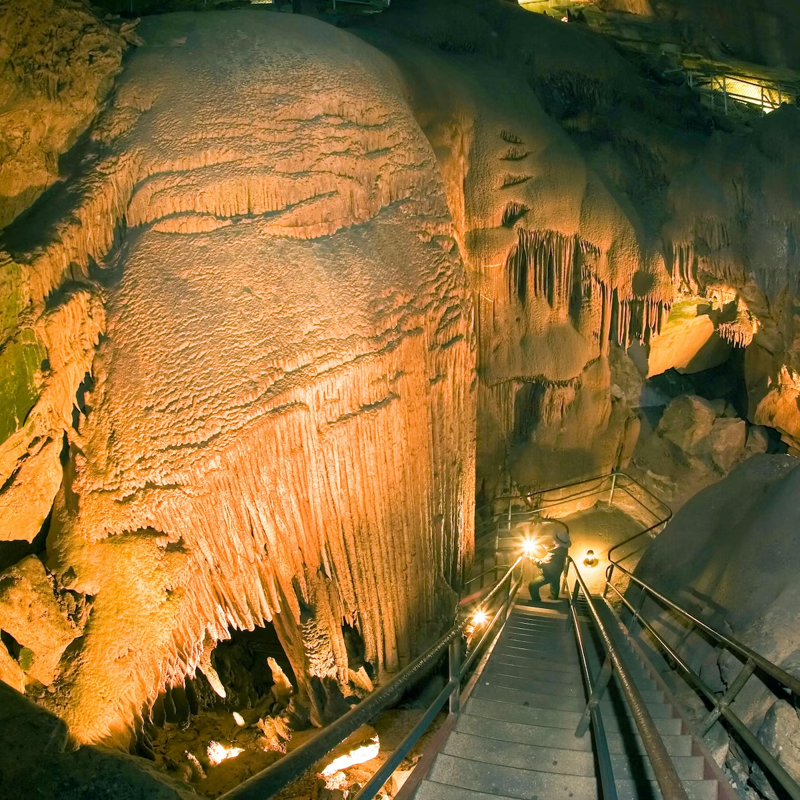
Mammoth Cave, https://www.lonelyplanet.com/usa/kentucky/mammoth-cave-national-park

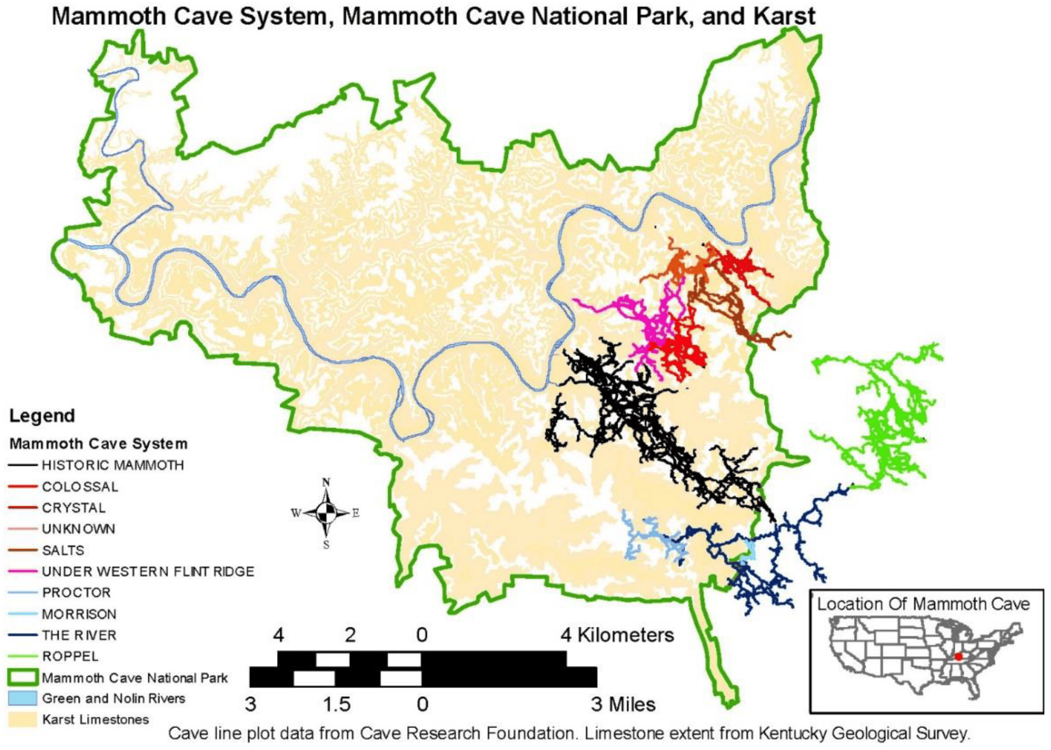
The National Park and Caves, including added cave systems (including Floyd’s Crystal Cave). Niemiller et al. 2021

